July 31, 2020

Dear Frances McClelland Vision Award Selection Committee,
I would like to nominate Patricia Harrison-Monroe, Ph.D., for the 2020 Frances McClelland Vision Award.
Dr. Harrison-Monroe is Associate Professor of Psychiatry at the University of Arizona College of Medicine in Tucson. She is an active educator and clinician and has a 20-year track record of making seminal contributions to the improvement in access to quality mental health services for youth, adults and families in Pima County and all of Southern Arizona.
During my tenure here in Arizona, the most significant contributions to public mental health have consisted of Dr. Harrison-Monroe’s visionary leadership in developing the Banner-University Medicine Whole Health Clinic and, in particular, the co-located Early Psychosis Intervention Center (EPICenter).
The EPICenter is a unique program that provides bio-psycho-social wrap-around services for teenagers and young adults who are experiencing their first psychotic episode or are in an early stage of psychotic illness beyond that first break. The approach is family-focused with family therapy and group therapy interventions complementing individual work. The EPICenter is the only comparable program in the nation to offer a five-year structured experience. Dr. Harrison-Monroe serves as the Director, working with a team of clinical psychologists and psychiatrists. The program’s goal is to catch psychotic illness early and intervene to start rehabilitation early, before the seemingly inexorable functional decline has begun. I have personally attended several “graduation celebrations” when young men and women, after five years in the program, expressed their appreciation that EPICenter had helped them “get it together” to enroll in community college, successfully apply for an entry-level job, develop wholesome leisure time pursuits and build lasting friendships.
Dr. Gustavo Perez, lead psychologist at EPICenter, says of Dr. Harrison-Monroe’s work: “Patricia is a true mentor and leader in our community, particularly in regard to serving young people with psychosis and other mental illness and their families. I have had the privilege of presenting with her at many community events, from schools and churches to detention centers and have witnessed her passionate advocacy for more equitable and comprehensive services for youth struggling with serious mental illness. Dr. Harrison-Monroe is a bridge builder who meaningfully and tirelessly connects with unrepresented communities – often outside of regular hours – to educate, support, encourage, and share better ways to care for our youth. I also admire her relentless quest to innovate and improve our program. At any given time she can be writing a technology grant to help our families stay connected during the pandemic, training new psychology and medical students, or advocating for expansion of services at our clinic. Her energy is contagious, and her leadership is inspiring.”
As is typical of Dr. Harrison-Monroe’s approach to challenges, she combined the design and implementation of the novel clinical service with an educational component that trains both clinical psychologists at the predoctoral level and psychiatric residents in the EPICenter. This training paves the way for new generations of mental health clinicians to be versed in this approach to serious mental illness, contributing in the long term to the prevention of long-term morbidity.
The design and implementation of the EPICenter, which has by now grown to an enrollment of more than one hundred families, is an outstanding example of a distinguished clinical-academic career devoted to the improvement of the lives of the mentally ill in our community. I believe that Dr. Harrison-Monroe is eminently qualified to be honored with the 2020 Frances McClelland Vision Award.

Sincerely,
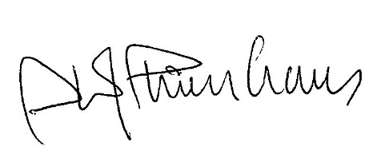
Ole J. Thienhaus, MD, MBA
Professor and Chair
Department of Psychiatry

