Memory Reconsolidation, Emotional Arousal, and the Neuroscience of Enduring Change: Implications for Psychoanalysis.

Lecture 1
(3/7/23)

Talk Moderator, Stephan:
Let me briefly introduce to you Richard Lane. He is a professor of psychiatry at the University of Arizona and is mainly into the field of neuroscience, specifically science related to the memory of emotions. He created the very well-established levels of emotional awareness scale. He is now researching the mechanisms of change in psychoanalysis and psychotherapy,

Richard Lane:

I want to thank Stephan, for everything he has done to help make this fellowship possible. And of course, the entire staff at Sigmund Freud Museum has been extraordinarily welcoming.

I also want to thank the University of Arizona, Medizinische Universitat Wien, the neuropsychoanalysis association (NPSA), Fulbright Austria, and the Sigmund Freud Museum.

This is the outline of the talk today. We'll talk about 1) Why we're taking a neural systems approach to enduring change in psychotherapy and psychoanalysis. 2) We'll spend a few minutes talking about the phenomenon of memory reconsolidation. Fascinatingly, the first person to describe memory reconsolidation was Sigmund Freud in 1896, he called this memory pretranscription. 3) I'll say a bit about memory emotion interactions. 4) Lastly, we're going to talk about the implications for clinical practice and implications for clinical research in a very cursory manner.

Okay. So why do we need a theory of how psychotherapy works? Well, first we can ask, what are the essential ingredients of any given modality? Can it be improved or be made more efficient? I’m going to take the position that psychoanalysis comes from a long tradition, and has had a lot of success, but I think that it can potentially be made more efficient if this model is taken seriously. That is an example of a controversial statement that hopefully can stimulate discussion.

What should be taught to trainees learning psychotherapy? Is an integrative framework possible? In the United States, psychiatry residents are required to learn psychodynamic psychotherapy or some exposure, cognitive behavioral therapy, and supportive therapy. In some ways, the theoretical foundations of CBT, psychoanalysis and psychodynamic psychotherapy are in opposition to one another. What is important to teach people, and it is possible to provide an integrated framework? I think that a major motivation for my doing this work and creating this model was for exactly this purpose. I have spent over 30 years as an educator in psychiatry training psychiatry, residents, and psychotherapy. These are very challenging questions. How do we integrative these therapies with different patients? How do we select which therapy to provide for a given patient? If we understand how therapies work and how they differ, this should be possible. Is there a place for psychoanalysis? I think it is by elaborating this model that we may be able to define under what circumstances we can broadly use certain modalities.

Can we understand the neurobiology of change? I think that this model provides some hints about that. I think it is also a guide for future research. The goal is to predict, using objective measures who will respond to which therapy. I think that's a long way off for the time being, but this model may be a start in that direction. Alan Kazdin at Yale said, “after decades of psychotherapy research, we cannot provide an evidence-based explanation for how or why even our most well studied interventions produce change.” That is the mechanisms through which treatments operate.” Frontline psychotherapy research typically involves defining the modality to treat patients. But to really define why change might be happening? That's never really been clearly defined for any modality.

This whole fellowship is an honor to Freud, and in some ways, I feel like what we're doing here is trying to bring Freud's dream to reality because he was originally a neurologist, here in Vienna. He saw patients with conversions and symptoms known as “hysteria,” and wanted to understand what that was all about. Freud hoped to have a neuroscientific explanation and invented psychological models. Here are some relevant quotes from Freud in 1914: “We must recollect that our provisional ideas and psychology will presumably someday, be based on an organic substructure. We're taking this probability into account and replacing the special chemical substances by special psychical forces.” In 1920, he said that “The deficiencies in our description would probably vanish if we were already in a position to replace the psychological terms by physiological or chemical ones.” In 1920, Freud stated, “Biology is truly a land of unlimited possibilities. We may expect it to give us the most surprising information. We cannot guess what answers will return, despite a few dozen years to the questions we have put to it.” That was a century ago.

To introduce this idea of mechanisms I like to show this slide of my beautiful home in Tucson, Arizona. This is a sunset in Tucson. We're used to saying, the sun sets in the west, but is that what's happening? Why does the sun disappear over the horizon in the evening? Well, if the sun set in the West that would really correspond to the sun rotating around the earth, which was Aristotle's model of the universe. We know now that the earth is rotating around the sun. It's only that the sun appears to set in the west, we know that the earth is rotating on its axis. That's why the sun disappears. The key point is that to the human eye these mechanisms look identical, right? The mechanism underlying phenomenology matters a lot. You could explain ego through a psychotherapy and psychoanalysis lens, or you could explain it based on neuroscience. It makes a difference. When you understand the mechanisms, new worlds of thought open. Going back to Isaac Newton, and his discoveries on the basic laws of physics, 350 Years later we have the Hubble telescope, and a couple of decades later, the same view as seen by the James Webb Space Telescope allows us to learn an enormous amount about the external world.

Where are we in regard to our exploration of the mind and brain relations? Well, we've had functional neuroimaging for 40+ years, and we've learned a lot. But I think that in many ways we're kind of still in the very early days, right? It reminds me more of Galileo, who was the first person to use the telescope and where we are today with the high-density definition of the Hubble telescope. Even with today’s technology, we have a long way to go - which is very exciting!

I would like to tell you about the seminal study that was conducted and published in the year 2000. This is over a century after Freud first described memory reconsolidation (Freud called this “retranscription”). It took a century before the scientific community accepted that memory reconsolidation happens.

Briefly, a little terminology: When you convert a short-term memory to long-term memory that's called memory consolidation. Once long-term memory is reactivated, it can be updated, revised, and stored again. That is called reconsolidation and is the premise of this 2000 paper.

In this paper, rats were conditioned by pairing a tone (conditioned stimulus) with a foot shock (unconditioned stimulus). Then, the scientists made the rats wait 24 hours, including a night of sleep for protein synthesis to occur. After 24 hours of protein synthesis, the rats froze when exposed to the conditioned stimulus, but did not freeze when exposed to the untrained tone. A third group of rats were given a drug, anisomysin, that blocks protein synthesis. This can be injected directly into the amygdala to block protein synthesis. If you condition the rats, wait 24 hours, and then give anisomysin to the rats, the rats still freeze. However, if you ring the tone and inject anisomysin at the same time, and then wait 24 hours, the rats do not freeze. Reactivation of the memory with the tone (conditioned stimulus only), puts the memory in a labile state. Injection of a protein synthesis inhibitor into the amygdala during the conditioning erases the memory. This leads us to think that whenever memories are retrieved, they are available for updating and reconsolidating new information presented in the labile state.

That is interesting! It is even more interesting when you consider that memory is not just for recalling the past. It is a guide to the future. Memory is adaptive because it keeps a record of what did and didn't work in the past. The key benefit is that it serves as a guide to similar situations in the future.

In fact, the brain is constantly making predictions about what's happening now, and likely to happen in the near future, based on these memories. Having some capacity to update memories in light of changing circumstances, can optimize, and allow us to flexibly adapt. However, changes must be made prudently.

I published a paper with Dr. Lee Ryan, Dr. Lynn Nadel, and De. Les Greenberg in Behavioral and Brain sciences journal called, “Memory Reconsolidation, emotional arousal, and the process of change in psychotherapy: New insights from brain science.” In this paper we produced a model called the integrated memory model.

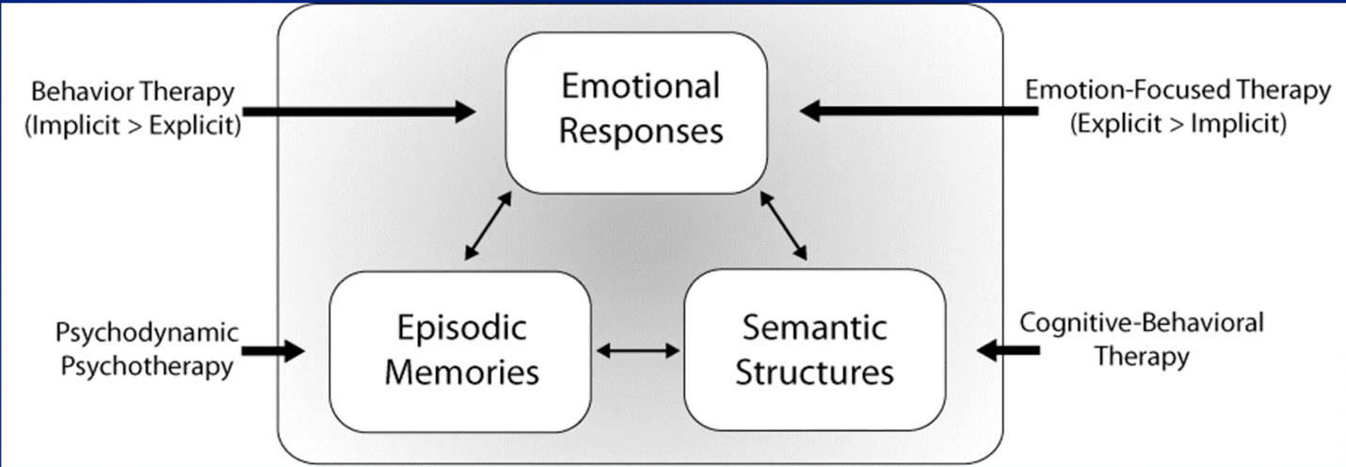
Figure 1. Integrated memory model

This model suggests that episodic or personal experiences, semantic structures or generalizable.
knowledge, emotional responses, and arousal action go together. It's impossible to activate one without the others. For example, I was honored to give a talk at the Freud Museum last week. I talked about the semantic structure of my concept of the Freud Museum. It has been a holy shrine in psychiatry. I had visited the museum previously 3 times in Vienna as an outsider. A week ago, here I was giving a talk at the Freud Museum, sponsored by the Freud Museum, and now I was a part of the program, and that was very meaningful. So that experience, the episodic memory and the emotional response has updated my schema of the Freud Museum. My schema is much more elaborate and personal now.

The idea is that people have schematic memories that are the basis of their recurrent maladaptive patterns. Episodic experiences in therapy and through interaction with therapists are emotionally charged and can update those schematic memories. In the Behavioral and Brain sciences paper we had a section on how emotional arousal is necessary for therapeutic change. In this paper we talked about several different modalities, including psychoanalysis. We pointed out that high physiological arousal during exposure therapy is a predictor of its efficacy. Multiple studies of emotion focused psychotherapy show that in session arousal is associated with better therapy outcome. In psychodynamic psychotherapy, insights without adequate, effective engagement are unlikely to produce lasting results. I trained in psychodynamic psychotherapy in the 70s and I have always known that effective engagement was necessary, but I didn’t know what that exactly meant. When is there adequate, effective engagement? This model provides guidance in that regard.

Emotional arousal has a special relationship with memory. Synaptic plasticity which is the molecular basis for encoding memories is enhanced by neurotransmitters and hormones, for example, norepinephrine and cortisol are activated by emotional arousal. We can't remember everything, but we need to remember what's most important. And this is one of nature's ways of ensuring that we remember what's most important.

I presented the Integrated memory model, and we said that that was the basis for change for all of these modalities. We highlighted 4 modalities in this paper. We made the point that the therapies look differently and are conducted differently. If they do operate through the same mechanism, how do they differ? Well, they differ in the entry points into the mode. In psychodynamic psychotherapy we highlight episodic memories, what happened to you recently, in the past, between the two of us in therapy? We also highlight semantic structure in cognitive behavioral therapy. For example, what are the thoughts that you have that are leading you to be depressed? In emotion focused therapy, that came out of the gestalt tradition. There is a lot of focus on vivid emotional experiences or conscious experiences that are experienced fully in your body. That is what we call explicit emotion. We have a whole chapter on implicit and explicit emotion that you'll read and enjoy, no doubt, but implicit emotion is the bodily expression of emotion - visceromotor and somatomotor expressions. In behavioral therapy and exposure therapy, when you want to get that heart rate up, that's an implicit emotional response.

The book I will be discussing is called the Neuroscience of Enduring Change – Implications for Psychotherapy.

During a conference in Tucson in 2017 we had all the authors come to Tucson. There are three basic sections of this book. One is on the basic science, perspective on memory emotions, their interactions with sleep and things like that. Then there is a clinical psychotherapy perspective section, experts who do different psychotherapy discuss how they view change. They address the extent to which memory consolidation didn’t fit in their perspective. The last three chapters include my chapter on recurrent maladaptive patterns which you may read for next week, a chapter on computational mechanisms, and the last chapter on the research agenda going forward including basic and clinical research. It was at this conference in 2017 that the four of us, the authors of this paper, met for the first time in person. We recognized there was something interesting about the last name of the authors. The last name in order of authorship Lane, Ryan, Nadel, Greenberg, spells out LRNG, so we call it the LRNG Model (figure 2).
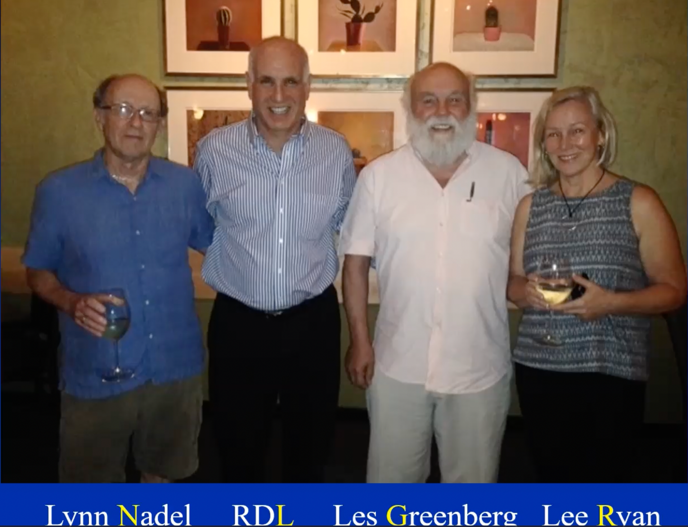
Figure 2. Tucson Conference with authors of the BBS paper.

The learning model I created with my colleagues provides 3 essential ingredients for entering change.
- First, you must activate old memories and old feelings, usually painful feelings, with or without awareness of their connection to the past. In psychoanalysis we have the phenomenon of transference where you might start experiencing your therapist, as a father, or as your mother. You don't necessarily remember that you feel that way because of that experience. This is an example of the memory being activated and influencing your perception.
- The second essential ingredient is to concurrently engage new emotional experiences that change old memories through reconsolidation. You’re activating the memory and putting it into the labile State. That memory is available to be updated with new information. We are going to highlight the idea of corrective emotional experiences.
- Then the third step is to reinforce the strength of new memories and their semantic structures by practicing new ways of behaving and experiencing the world in a variety of contexts.

A way of understanding the change is making the transition from episodic memories to semantic structures. A core idea here is that semantic memories or generalizable knowledge, is a result of a distillation of episodic memories or episodic experiences. To illustrate this point, we have this simple example. A child goes to the park and sees some creatures, let’s say a robin.
It's a medium sized bird that is red.

The child then sees dogs, cats, other squirls, but then it sees a canary. It's yellow and small, but it also has feathers and wings. The overlap between the robin, the canary, and other birds that the child might see, distills out. The generic concept of a bird becomes a word attached as a concept. It's a distillation of episodic experiences.

So how is this relevant to psychotherapy and the change process. Well, relevant features of recurring situations growing up are extracted, including who is involved, what transpires, how it feels, how to respond, and how others respond to you. These memories are the elements of the internal working model of how the world of social relationships operates. A way of thinking about this is you grow up in your home, you do the best you can, you adapt to the circumstances that you're in. They might be neglectful or abusive, hopefully not. But you must make adaptations, and you optimally adapt to the situation that you're in. But then you leave home, and then you're out in the adult world, and those adaptations cause some difficulties. Right? That’s what we mean about the internal working model of the social world.

That's exactly what we're going to talk about next week. Recurrent maladaptive patterns that have to do with the internal working model of the social world. That is a schematic memory. We're going to try to update that memory, particularly with emotional information which will then influence what expectations you have in social situations, how you proceed with them, and how you respond.

Recurrent Maladaptive Patterns: A Type of Schema. Clients often come to psychotherapy because they are unhappy with aspects of their social or occupational lives. They are typically unaware that this is part of a behavioral pattern triggered by interpersonal situations that are “reminders” of problematic situations from the past.

I'm not referring to schema therapy per se, but there is overlap with schema therapy. What I’m talking about is basically thinking about psychodynamic psychotherapy and psychoanalysis in terms of schemas.

When we talk about schemas, schematic semantic memories, internal working model, we’ll first use that term with the social world and recurrent maladaptive patterns. We're talking about the same thing. Research discussing how schematic change develops neurologically is quite limited. It's a ripe area for new research. We specifically define how in the brain schematic memories change during psychotherapy. We're just learning about how schematic memories are instantiated in the brain.

I'm now going to talk a little bit about other memory mechanisms to put memory reconsolidation in context. Memory reconsolidation is not the only mechanism of change, but it is an important one, because we think that it's the one most associated with enduring change. You're changing the memory and the blueprints for behavior. You're all probably familiar with classical conditioning. When you present the unconditioned stimulus during the bell ring, the bell becomes the condition stimulus. You pair the stimulus and salivary response and continue to ring the bell. Repeated presentation of the bell without the unconditioned stimulus leads to an extinction of the salivary response. The dog will initially salivate, however when you keep ringing the bell and the salivation stops this dynamic becomes the basis of exposure therapy.
The key point is that the original memory is suppressed by creation of a new memory.
The original memory is retained and can be reactivated under appropriate circumstances.
Essentially the bell creates a new memory, and it suppresses the memory that links the association between the bell and the food. Even though the salivation stops, that association is still present. Indeed, there can be reactivation of that association. In post-traumatic stress disorder (PTSD), for example, after exposure therapy, people may have reduced PTSD symptoms. But then something happens, or some other trauma presents itself, and the PTSD symptoms come back because the association is still there. What we're after is trying to change what has been learned, the associations that are there, so that symptoms don't recur.

What are elements of psychotherapy that may favor memory reconsolidation over extinction? In psychotherapy, we want to change memory through reconsolidation. But if you don't do it exactly right, you’re just going to suppress the old memory, and your memory will still be there. So, what determines whether it's one or the other? I can tell you that this is a very active area of research among neuroscientists, and the boundary conditions is still being figured out. It's a very complex area. A lot of smart people are working on it and haven’t figured it out. Gershman and colleagues at Harvard said, “the latent causal structure of a situation determines whether a new memory is formed or an old one is modified.” So, with the bell and the food, the latent causal structure of the situation with the bell only is fundamentally different from the bell plus the food, and that’s why a new memory is formed that suppresses this response.

Now here are some elements of this that are relevant to psychoanalysis. Memory reconsolidation is favored when the new situation resembles the old in many ways. Okay. So, in psychoanalysis, when you start developing a transference neurosis and start experiencing your analyst as someone from the past, the new situation resembles the old in many ways, and changes are slow and gradual, as opposed to abrupt. The memories that are harder to change or update are older, stronger, and more differentiated, which is one reason why many sessions may be needed.

So different types of memories with emotional content are the basis for different kinds of psychotherapy, if you will. So classical conditioning is associative learning that involves pairing stimuli and responses. Associative learning is an emotionally neutral content plus unrelated emotional arousal. So, for example, if a little boy starts playing with dolls, and the daddy scowls, the boy learns, maybe that's not a good thing to do. Through reinforcement learning the effective consequences of an action can change its value, right? So you start playing the piano and you're good at it, and you enjoy it, so you keep doing it. Or you don't like it very much, and you stop practicing. Episodic memories with strong emotional content versus memories without emotional content. An example would be traumatic memories or another category of memory with emotional content. And then we have schemas with inherent emotional content, such as implicit effective learning.

It's my opportunity to acknowledge Bruce Ecker who was the first person to write about the relevance of memory reconsolidation in psychotherapy. He uses the example of a man who came to him for help because he was in his fifties, and he couldn't hold down a job. He'd work for, you know, an employer for a couple of years, and then would quit and go on to change jobs, and it really wasn't progressing his career very much. And so, he met with Dr. Ecker.
who investigated his past, and they found out that the man's father had worked in a factory for many years. He had stuck with it actually for a couple of decades, because it paid pretty well and helped pay the bills, but he was miserable, and his dad kept saying when he was growing up, never stay in a job too long because you know it'll kill you. Don't get stuck on a job. So, once he realized and brought that to conscious awareness that was the first step. And then they started talking about other people that he knew who had been in a job for a long period of time and were very gratified. So, they kind of updated that schematic memory with new emotional information. And apparently, you know, the patient was much improved and able to hold onto a job and was very gratified.

To summarize the time courses of change: Episodic memories are the easiest to modify or change. Semantic memories (including schematic memories) are harder to update, although I would submit that even a single experience in psychotherapy – a corrective experience – can update a schematic memory enough to influence expectations. Procedural memory or habits are the hardest to update and it is controversial as to whether or not even those kinds of memories can be reconsolidated.
.
Okay, so SEPI is the Society for the Exploration of Psychotherapy Integration. This is a way of understanding how to think about fundamental change mechanisms in light of the fact that there are hundreds of different kinds of psychotherapy. We have 3 fundamental memory mechanisms relevant to change. We talked about memory reconsolidation which is updating or changing the original memory. We have talked about extinction which is suppressing the original memory and can be therapeutically helpful but prone to relapse. Then there is an alternative third one, which is new learning that doesn’t replace but can out compete the original learning. Another leading theorist, Mark Solms, is of the opinion that the problem people have in psychodynamic psychotherapy involves procedures that cannot be reconsolidated. So, what you can do is through insight, develop new procedures that out compete the old. So, these are three different fundamental common pathways. All therapies involve 3 key steps according to Jeffrey Smiths conceptualization. Jeffrey Smith is a psychiatrist in New York that is the head of the secretary of the caucus of the American Psychiatric Association. He is also the incoming president of SEPI. So, the three key steps to change are: reactivate, revise, and reinforce. You then have 4 facilitating factors for SEPI’s mission: you need to create a therapeutic relationship, create a sense of safety, motivate the patient, and help regulate arousal. Hopefully, this is helpful in terms of thinking how these fit into the fact that there are hundreds of different kinds of therapy. Something like EMDR probably works through the same mechanisms that I am talking about.

I am going to talk about three modalities: Psychodynamic Psychotherapy, CBT, and emotion focused therapy, and how this model fits. Active recall of past experiences promotes intense emotional experiences including new experiences, the transference, and the emphasis on working through in a variety of contexts is highly consistent with memory reconsolidation. Perhaps the process of creating trust, establishing the working alliance, and enabling and working within the transference constitutes critical, implicit, emotional learning that paves the way for new, explicit, corrective experiences.

If this is how change happens, is working on the recurrent maladaptive pattern within the transference relationship with the therapist always necessary? I would say that the answer is no. Perhaps activating old memories and having new experiences is sufficient in psychodynamic psychotherapy. Perhaps high frequency psychoanalysis, like 4-5 times a week, is indicated when working within the transference relationship is necessary to promote a systematic trust. That is, if you grow up and don’t feel that other people can be helpful and provide useful information to you. It takes kind of rebuilding and your whole faith in human relationships that require a lot of interaction.

Unsuccessful analysis maybe due to reliving the old experiences without having enough new experiences to alter the old memories. I think there was many years when the catharsis model was operative, to recall the old experiences – active the pain – and then see what people do with it without doing anything about it. Well, that can actually reinforce the painful memories and ingrain them deeper. I think sadly, of course, there are many people who benefit from psychoanalysis, but there are also a lot of experiences of people not benefitting including people in high places which contributed to the gradual decline in popularity. I am thinking that this model can help.

Implications for emotion focused therapy: Activation of old memories through reminders in the present is important even though explicit efforts to recall the past are not emphasized. So emotional focused therapy was put forward as an alternative to cognitive behavioral therapy which is very cognitive. As a result, there was a real focus on emotion. Les Greenberg famously said that you have to change an emotion with emotion (quoting Spinoza). I think that emotion is very powerful, and I don’t think you need interpretations to change. However, there are a lot of cognitive emotional interactions happening in emotion focused therapy that aren’t emphasized in the theory. Hats off to Les Greenberg who was happy to co-author this paper with us.

Semantic structures, not just emotions, are being updated. When clients are asked to adopt different perspective and share their work, it's an excellent technique for dealing with conflicts or unfinished business. People sit in one chair and talk from one side of the issue and then switch chairs and talk from the other side. This change really activates emotions and your juxtaposing conflicting emotions which is helpful. The effectiveness of emotion focused therapy may be related to the potent effect that emotional arousal has on memory. Activation of negative emotion may facilitate learning. This is a principle from computational neuroscience. The learning rate may be faster in the context of negative affect in emotion focused therapy. It's trying to activate the emotional pain. In other words, unpleasant arousal amplifies the degree to which prediction error updates memories. In computational terms, this occurs via altering precision-based modulation of prediction errors. New information is more likely to change the old prior conceptions in the context of negative affect.

The classic theory in Cognitive Behavioral Therapy is you change your thoughts; you change your feelings. Aaron Beck is a psychoanalyst and dealt with depressed patients who had a lot of negative thinking. He thought, maybe you think differently – view the glass as half full, not half empty which will influence your mood. Our perspective suggests a shift in emphasis. It may not be the change in thoughts that matter as much as the resulting change in emotional experiences in a variety of contexts that enable reconsolidation of memories.

So, emotion is a mechanism of change, not just an outcome. In other words, on the surface your change in emotion is an outcome, however in our model it is a mechanism of change. For example, let’s say there is something that happened in the past that you are very ashamed about, and you’ve never told anybody, and you tell your therapist. You expect to be rejected and ridiculed. Your therapist alternatively responds emphatically, compassionately, and non-judgmentally. That is a prediction error and a corrective experience. When you go out into the world, there may be a situation where you might be very apprehensive, you might have a little more optimism. You might think that it's possible that people will respond to you more positively. That’s an example of emotions changing your thoughts. That highlights the importance of successful homework. It helps to explain why rumination or unsuccessful homework is problematic. It further ingrains the old memories, just like activating painful memories without doing anything other than dwelling in the pain isn’t that helpful by itself. It highlights that the enduring change requires changing the semantic structures, the internal working model, not just reducing emotional distress by temporarily altering thoughts.

Consolidation and reconsolidation happen during sleep. Rapid Eye Movement (REM) sleep, preferentially, consolidates emotional aspects of memory. Put another way, emotional memories are to be consolidated preferentially during REM sleep. Is the same true for emotional memory reconsolidation? Most likely, yes. That casts a whole new perspective on dreams. As mentioned by Freud’s seminal book, “Interpretation of Dreams,” dreams might be a real time readout of memory reconsolidation as it is happening. It highlights the importance of sleep quality and duration. Clinically, we know someone who is depressed, anxious, psychotic, you name it, are often associated with sleep difficulties. Consequentially, we get people on medications to help them sleep. There are also behavioral techniques, such as CBT – I (Cognitive Behavioral Therapy-for Insomnia). Also, napping has been shown to enhance explicit recall of verbal material. When I was first learning about the whole area I said to a sleep researcher, maybe people should take a nap after a psychotherapy session? The researcher agreed and said you may want to encourage that because it helps rehearsal or corrective experiences at that time. There is real experimental work done that demonstrate that people rehearse what they learn before they go to sleep, and that content has been shown to be remembered better.

What if psychotherapy practice was based on memory reconsolidation principles? The reconsolidation window stays open after the session for 6 hours. So, arousal like exercise after a session, can tag what came before. A nap or sleep can lock in changes. Let’s say you have a beautiful session in your analysis, and then you go back to work, and you have a terrible experience an hour later. is that bad experience going to influence the process of change? It might. We don’t think about that at all. We focus on what happened in the session and it finished.

Issues to consider: why do we have a once a week session for 45 minutes or an hour? Maybe what we are after is having a corrective experience, and then you should take a nap. Maybe that can happen after 15 minutes? What about a retreat style intervention where you could have multiple sessions in a day? Why not? By paying careful attention to what you do after each session, (the reconsolidation window is open for only 6 hours), you might benefit from taking a nap.

Yes, we prescribe medications. For instance, SSRIs, SNRIs, tricyclic medications are used to treat anxiety. However, unfortunately, all of these medications reduce REM sleep. Yes, we help people with their symptoms but are we compromising patients’ abilities to take full advantage of memory reconsolidation?

Requirements for demonstrating that memory reconsolidation has occurred: There is a big difference between animal studies, like the rodent study that I mentioned, and psychotherapy. The steps to demonstrate memory reconsolidation through reactivation and manipulation interaction are, you can have reactivation, like playing the tone with or without the anisomycin; as well as without playing the tone with or without anisomycin. Neither of those steps should work. Instead, you have to show that it is the combination of the two manipulations that are required for memory reconsolidation. For time dependency, you have to present the tone within 4-6 hours to activate the memory. If you wait 6 hours and do the manipulation it shouldn’t work (that has been shown in animals). Imagine how you can test this in psychotherapy with memory specificity. You would have to do this manipulation with every activation of one memory, but not another. You have to be very specific about what memory you’re activating and changing. You may activate another memory, but not manipulate it, and show that it's only the manipulated one that you know.

The association of immediate and delayed effects: Sleep is necessary for reconsolidation. You need to demonstrate that immediately after the manipulation you haven’t seen the change, but you do see it the next day. You do see it in the long term follow up. The point being, currently, we cannot do this in psychotherapy, but we can approximate it.

Benefits of grounding theory and practice of psychotherapy in memory consolidation neurobiology: With regard to practice, it provides general guidance in executing therapy; it also provides specific guidance in the face of uncertainty. If your therapy is stalling or failing, it may be useful to think about this model. With regard to research, studies provide an empirical grounding of concepts and processes that provide methods for measuring changes based on memory reconsolidation. It is a source of new predictions and hypotheses, for example, sleeping, napping, and dreaming.

General conclusions: Therapeutic change in a variety of modalities may result from the reconsolidation of emotional memories by incorporating new emotional experiences in contexts reminiscent of the original problematic situations. Change in psychotherapy has 3 necessary ingredients: activate old memories including the old feelings, activate new emotional experiences, and practice new ways of experiencing the world in a variety of contexts. This model may apply to all psychotherapy modalities that aspire to achieve enduring change. Certainly, psychoanalyses has aimed to induce enduring change.

Some caveats and cautions I would suggest: Memory reconsolidation has not been unequivocally demonstrated in humans, although much evidence exists (we will talk about some of that evidence in following lectures). Alternative explanations still cannot be excluded. Case examples lack experimental controls that are needed to meet the most rigorous standards of proof. However, lack of definitive proof doesn’t mean it's not occurring. Little is known about reconsolidation of semantic or schematic memories – an important growth area. The best we can do is make predictions, get results, consider, and rule out alternative explanations when possible. I want to thank my co-authors, people involved in the BBS paper, as well as my sponsors, Fulbright Austria, The University of Arizona, Medizinische Universitat Wien, Sigmund Freud Museum, and NPSA, without whom none of this would have been possible. Thank you.

Nader K, Schafe GE, Le Doux JE. Fear memories require protein synthesis in the amygdala for reconsolidation after retrieval. Nature. 2000 Aug 17;406(6797):722-6. doi: 10.1038/35021052. PMID: 10963596.
Lane RD, Ryan L, Nadel L, Greenberg L. Memory reconsolidation, emotional arousal, and the process of change in psychotherapy: New insights from brain science. Behav Brain Sci. 2015;38:e1. doi: 10.1017/S0140525X14000041. Epub 2014 May 15. PMID: 24827452.
Lane, R. D. (Ed.). (2020). Neuroscience of enduring change: Implications for psychotherapy. Oxford University Press. https://doi.org/10.1093/oso/9780190881511.001.0001

