Memory Reconsolidation, Emotional Arousal, and the Neuroscience of Enduring Change: Implications for Psychoanalysis.

Lecture 2
(Live recording 3-14-23)

The topic today is recurrent maladaptive patterns. That was a chapter in the book that I wrote. Why are we interested in this? Because it's the problem that we're trying to treat. I’m going to give you a little outline of what I’m going to talk about today. First, I’ll introduce the concept of repetition compulsion put forward by Sigmund Freud. Later in the talk I will return to Freud's writings about the death instinct. After that brief introduction we'll then talk about current psychodynamic approaches to recurrent maladaptive patterns. I will have some material elaborating on what we talked about last week, which is that recurrent maladaptive memories are schematic memories involving the internal working model of the social world. We'll then switch gears and talk about the second reading which is the Boston Change Process Study groups work on the implicit process of relational knowing, which is based on more recent child development research and its implications for psychotherapy and psychoanalysis. Following from that, we will provide a review of core psycho dynamic concepts, like the unconscious development defenses and treatment. We'll compare traditional concepts to the newer perspective that I’m offering. I'm going to feature a computational perspective on recurrent well adaptive.
Freud’s concept of repetition compulsion. His first use of the concept was first defined in 1914, in this article, “Remembering, Repeating, and Working Through.” Repetition Compulsion is the unconscious tendency of a person to repeat a traumatic event or its circumstances. This may take the form of symbolically or literally re-enacting the event, or putting oneself in situations where the event is likely to occur again. Freud says, “the patient does not remember anything of what he has forgotten and repressed, he acts it out, without, of course, knowing that he is repeating it. For instance, the patient does not say that he remembers that he used to be defiant and critical towards his parents’ authority. Instead, he behaves in that way to the doctor.” I want to share with you the experience that I had in working on this material. Last week I went to the Freud Museum, I try to go there as much as possible. They're sponsoring this fellowship. I was reading Freud’s original work on repetition compulsion in Freud’s home. I was immediately filled with lots of feelings. I returned to my undergraduate days, 50 years ago, when I read Freud for the first time. I loved it, and I just was filled with admiration for his insights. I remember how much I enjoyed the feeling of getting some answers to questions about why people behave the way they do. I also was reminded of the strong feelings of attachment I felt for the people who were teaching me this stuff. My father was a psychoanalyst, and these professors at Yale I had feelings of love and admiration for these people. Then I thought about my plan for the day. After I was going to refresh myself about what Freud said and then I was going to develop this lecture and talk about my perspective that kind of disagreed with Freud or went beyond Freud if you will. I was overwhelmed with a feeling of guilt because here I was in his home. How dare I be so sacrilegious? It was really a strong feeling of I can't do this. I had to excuse myself, go for a walk and get my head clear. What I determined was that I was going to say some things that Freud wouldn't necessarily agree with or certainly didn't say. However, in the end Freud was a scientist, and really what I’m trying to put forward is the idea that we're trying to put what we're talking about on a scientific basis. I think he would approve.
It also occurred to me that there was something significant about that whole sequence. I wondered if that strong feeling, like you shouldn't be thinking this or working on this, was the basis for repression. Not allowing oneself to think certain thoughts because of their emotional consequences. I also wondered about people who have spent their entire career as psychoanalysts. How they might have a hard time accepting what I’m presenting because, among other things, it may create intolerable feelings of disloyalty to all the colleagues and teachers and one's own world view that one holds steer. I think there's a lot of stakes here, and I think we're dealing with some fundamental processes.
I think recurrent maladaptive patterns are an expression of implicit emotional memories. Clients often come to psychotherapy because they're unhappy with aspects of their social or occupational lives. They're typically unaware that this is part of a behavioral pattern triggered by interpersonal situations that are reminders of problematic situations from the past. The problematic response to these situations consists of behavioral patterns that AIM to assure avoidance of the experience of intolerable emotion.
I’m now going to present Karl Meninger's two triangles: the triangle of conflict, and the triangle of insight. I've been using these triangles regularly in the seminars that I teach to help people get a grasp of what the recurrent maladaptive patterns are as they try to formulate what's going on with their patients. Karl Manager talked about two different triangles. One was intrapersonal, the triangle of conflict, and the other was interpersonal, the triangle of insight. The triangle of conflict involves, hidden feelings, defense against those hidden feelings, and when those defenses aren't adequate, anxiety or distress. The experience of these hidden feelings, or intolerable feelings are destabilizing. Then there's the triangle of insight which is interpersonal. The first corner of the triangle is the family of origin where the pattern gets started. The second corner represents other current relationships, which is typically a situation that brings people in for therapy because they're having some challenges in their current relationships. And then the third corner that represents the transference. The idea is that the same pattern will manifest itself in interaction with the therapist if the proper conditions are setup.
Let me give an example of a recurrent maladaptive pattern. I'm going to refer to the case of Becky. It was treated by Hannah Levenson who developed time limited dynamic psychotherapy. I use this case because it was a very effective treatment, and the entire treatment is available online. You can see it in its entirety from beginning to end. Moreover, there are a number of papers that have been about it, and more and more research is being done on it because it was a such a beautiful therapy and effective. Becky is 25 years old, her mother was alcohol dependent, and required that Becky attend to her mother's needs. The father was also pretty demanding an expected top performance from Becky. As a result, Becky became perfectionistic and learned not to impose her needs on other people. We have assessed the family of origin. Now she's leaving home and has a boyfriend. Becky loves her boyfriend, but he was often inconsiderate. She kept her feelings to herself, and often cried herself to sleep. This is what she had learned to do from childhood up bringing. The therapy involved paying attention to her emotional pain, recognizing the needs that you have that were captured by the pain that she had by virtue of interactions with the therapist coming to feel that she was worthy of being treated well, and then acting in her relationships to increase the likelihood that her needs would be met. This is a kind of an encapsulation of the three processes that I mentioned previously. The essential ingredients for change. You must activate the old memories and the painful emotions associated with it, have corrected experiences, and then use situations differently and respond differently in practice, and in different contexts. How can we map Becky's case onto these two triangles? Well, first, the hidden feeling is that she's afraid of rejection. Her relationship with her boyfriend wasn’t as strong as she wanted it to be. Her defense presented as trying to be as perfect as possible. When that didn't work, she was distressed because the considered behavior continued. When considering the family of origin, she learned to take care of her parents and her current relationship she was taking care of her boyfriend. This therapy, which only lasted 6 sessions, wasn't long enough for her to develop transference feelings in in the therapy relationship. On the other hand, the therapist was concerned from the get go that she was very inclined to please her and be a good patient.
A very important point is that we can make a connection here between symptoms and recurrent maladapted patterns in the triangle of conflict distress. Symptoms arise when the avoidance function of the triangle of insight does not continue to work adequately. The intolerable emotional distress was that was avoided, is now consciously experienced. Symptoms may be treated and improved in a variety of ways (e.g. medication, symptom focused psychotherapy, and sometimes just with the passage of time symptoms dissipate). However, if the recurrent maladaptive pattern is unaltered, the risk of recurrence is high. To alter the recurrent maladaptive pattern, psychotherapy leads to better symptomatic improvement compared to medication alone and much lower risk of recurrence.
I'm happy to say that because of the interactions we had, both here and online, I'm introducing some material that speaks to it because one of the questions I was asked was, how do you define schemas? There are two definitions of schemas which should resonate with what we talked about last week. Schemas are defined as “superordinate knowledge structure that reflect abstracted commonalities across multiple experiences, exerting powerful influences over how events are perceived, interpreted, and remembered.” (Gilboa & Marlatte, 2017) Now, here's a definition from Beck and Haigh (Beck & Haigh, 2014), who promote cognitive behavioral therapy. “Internally stored representations of stimuli ideas or experiences that influence, automatic and strategic conscious information processing.” As I said last week, schemas or type of schematic memory, which is a subcategory of semantic memory, internal working model and recurrent maladaptive patterns are schematic memories. These four examples from the psychodynamic literature that basically are different ways of conceptualizing recurrent patterns that constitute schemes.
How does this relate to Schema therapy? The case of Becky fits into the schema over vigilance and inhibition. Be careful and restrained at all times. People with schemas and the over vigilance, and inhibition domain, emphasize performance, following rules and fulfilling duty over pleasure, joy, and relaxation. They may be perfectionistic, suppressing their emotions and impulses to meet rigid, internalized expectations. Early childhood experiences may include demanding or punitive parenting with a lack of play and self-expression. It sounds kind of similar to what we talked about with Becky. They talk about three different configurations. It seems to fit the best emotional inhibition. Emotions, behaviors, and communications are shut down to avoid disapproval by others, or feelings of shame. The treatment goal for skill-based therapies are to learn to become more emotionally expressive and playful, teach strategies to appropriately express anger and discuss unexpressed emotions, discover that emotions are normal and healthy, not to be shamed or neglected, encourage spontaneity, play an expression of love and or affection. I think that the issue where the difference between psycho dynamic approaches and more skill-oriented therapies comes from the approach to treatment. How do you learn these new things? Can you just practice some skills and overcome these deep-seated problems, or do you have to do some something more definitive, that's related to the fact that these problems are there serving the function of keeping intolerable affect at bay? Hannah Levinson really sensitized me to the critical importance of interpersonal processes and psycho dynamic psychotherapy. The problem starts in the context of relationships that we talked about, in the triangle of insight. People seek help because they're having problems in personal contexts, social and/or occupational, and the problems get resolved with interaction with the therapist. Those are all interpersonal. Working with affect and creating corrective emotional experiences is the key to successful treatment.
Recurrent maladaptive patterns are not recognized as important from other major psychodynamic psychotherapy modalities. There are three reasons that I talked about in the chapter. First, one of the ways that psychoanalysis and psychodynamic psychotherapy differ is a focus on etiology as opposed to maintenance factors. I think people who do Cbt, for example, would say we can't possibly know where these problems came from. What we can do is we can address what's maintaining them. We do try to reconstruct what happened in childhood, but we also recognize that memories are constantly being updated. We also recognize that we can't necessarily know exactly what happened. But we can understand the person's current version of what happened, and that may be what's maintaining the problem. A second major difference is that, in all other therapies, the therapy relationship is facilitated and supportive. However, in psychodynamic psychotherapy it particularly is psycho analysis, and the therapy relationship is the context for the intervention. The most effective approach is to get to that third corner of the triangle with the transference, and work things out there. Another reason why recurrent maladaptive patterns which are the cornerstone of psychodynamic psychotherapy have been ignored is because of the view that psychodynamics is not as scientifically based as one would ideally like to see. There's traditional disinterest within psychoanalysis in objective scientific validation. It was thought that it really wasn't going to add very much and would cause problems. To make objective measurements in the context of the therapy would introduce an objective, evaluative aspect to it, which could be counterproductive. However, the question beckons, how are you going to measure change? Are we just interested in symptoms, or something more? The answer is in psychodynamic psychotherapy, and psychoanalysis we're interested in something more - a broader frame of reference beyond symptoms and diagnoses. Symptoms and diagnoses fit our medical reimbursement system very well. Our current symptom-based nosology is flawed and is widely acknowledged to need revision. We don't have a good alternative yet, but RDOC (Research Domain Criteria) approach developed by the National Institute of Mental Health in the US is trying to find alternative, evidence-based ways of categorizing psychiatric disorders. The point is that we have a system that isn't wonderful.
How can we better capture the range of what people potentially want and need from psychotherapy, for example, in altering how they perceive and interact with others? The adaptability, flexibility, and generalizability of the internal working model guiding perceptions and actions and their personal relations can be thought of as a measure of psychological health. I found it very helpful in teaching psycho dynamic psychotherapy, to consider a continuum of mental illness and mental health. In psychiatry we're thrilled when the patient goes into remission, which means that there are no more symptoms. Are they really flourishing and getting the most out of life? What more could be done? How do you really think about that above and beyond symptoms? I found this definition of mental health from Shedler very helpful. This is a great article reviewing very strong evidence that psychodynamic psychotherapy works and that it is every bit as effective as other modality, and every bit, if not more effective than psychotropic medication.

Table 1
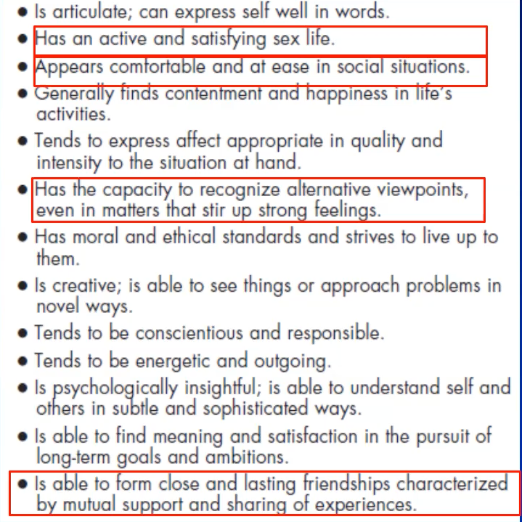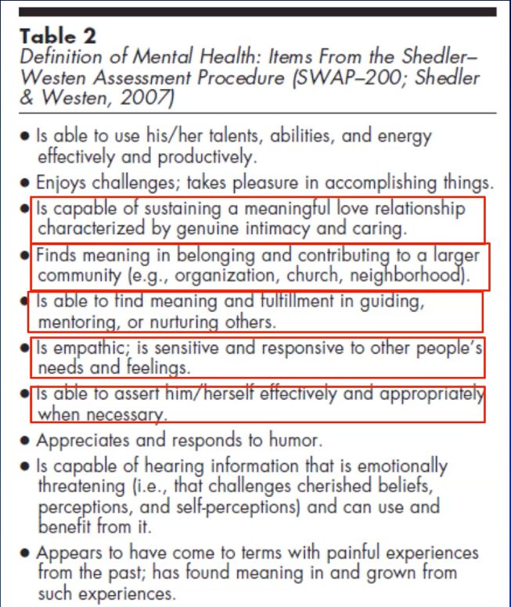

I have highlighted with the light red boxes these aspects of mental health that are social and interpersonal right. Is able to use his or her talents, abilities, and energy effectively and productively, enjoys challenges, takes pleasure in accomplishing things, is capable of sustaining a meaningful love relationship, characterized by genuine intimacy and caring, finds meaning and belonging and contributing to a larger community, is able to find meaning and fulfillment and guiding in mentoring or nurturing others, is empathic, is sensitive and responsive to other people's needs and feelings, is able to assert him or herself effectively and appropriately when necessary, appreciate some response to humor, capable of hearing information that's emotionally threatening - that challenges cherished beliefs, perceptions, and self-perceptions, and can use and benefit from it, appear to have come to terms with painful experiences from the past, found meaning in and grown from such experience, is articulate can express self and words as an active and satisfied sex life, appears comfortable and at ease in social situations, generally finds contentment and happiness in life's activities, tends to express affect appropriately, and quality and intensity to the situation at hand, has the capacity to recognize alternative viewpoints even in matters that stir up strong feelings, has moral and ethical standards, and strives to live up to the, is creative, is able to see things or approach problems in novel ways, tends to be conscientious and responsible, tends to be energetic and outgoing, is psychologically insightful, is able to understand self and others and settle in sophisticated ways, is able to find meaning and satisfaction to pursue long term goals and ambitions, is able to form close and asking friendships characterized by mutual support and sharing of experiences. I find this useful when thinking about patients, and reviewing their symptoms, and when the symptoms are kind of at a lower level, considering what more might need to be done? What might you want to work on in psychotherapy? If people can do all these things, I think they're very healthy. *Question is asked by student. The question was, do you have to have all of these? No, I think if you have all these, you're really in the great shape, right? The question is, how many of these aren't you able to do, and then you make a judgment about whether there's something to work on right and discuss with the therapist about whether what you're working on can lead to improvement in these areas. *Follow up question by student. The question is, are there rules regarding how many points you must have to be healthy or not? No, It's not a checklist. It's not a rating scale. It's a conceptual guide to the kinds of things we're interested in.
Here's a way of thinking in broad terms about differentiating between the four modalities that we're covered in the Bbs paper. Behavior, exposure therapy is especially useful for specifically identifiable situations that elicit the maladaptive response, like a spider phobia for example. CBT, or emotion focused therapy is especially good for symptomatic syndromes that are temporary disturbances and emotional responses such as clinical depression, anxiety states that are not situation specific. Whereas psychodynamic insight-oriented psychotherapy, is best for and during trade characteristics that are not temporary and not situation specific. We're trying to identify what's the place of psychoanalysis and psychodynamic psychotherapy relative to other modalities. Clinical psychoanalysis faces many challenges. Psychoanalysis is both a model of the mind and a mode of treatment and at the Freud Museum there's extensive work going on. Psychoanalysis is a model of mind in the humanities and social sciences, and that's thriving. However, psychoanalysis is also a mode of treatment, and unfortunately, it's kind of on a decline. For example, in Germany I heard there were 89 professors of clinical psychology and 88 specialized in Cbt and there's one that specializes in psychoanalysis.
Insurers prize brief structured interventions, that are cost effective. Symptom change as a primary outcome is limiting because I've explained. Teaching psychoanalysis is challenging due to a plethora of ideas according to a finding. There are many different schools of thought that have emerged through the years. Psychodynamic psychotherapy is hard to pin down and it's challenging to teach.
Countertransference limits the analyst’s role as a researcher. The thought was that the psychoanalytic consulting room was a laboratory and we're exploring the depths of the human mind in a way that is not explored. We now know about the inevitable role of counter transference. It is a good thing once you understand what it's all about. That's the feelings that the therapist and analyst have toward the patient. You must differentiate between those things that are unique to the person, to the therapist and those things that are emotional responses that are indicative of what every other person, or most other people would experience an interaction with this person. It's a real clue to how the recurrent maladaptive pattern continues because it's thought that, because it induces emotions in the other person, and they act in certain ways that repeat the pattern. As a therapist, you can experience that yourself, recognize it and not act on it. It's very valuable, but it makes the enterprise of research less objective than what we would like. In fact, genuine objective research tradition is lacking, and it is argued that a comprehensive model of the mind must be open to other perspectives. That is some background for why I’m teaching this course and doing the research that I’m doing.
This is a quote that I've received from an email in 2017 from Dr. Horst Kachele. He has unfortunately passed away. He was the former chair of psychotherapy and psychosomatic medicine, in the University of Ulm Germany. He wrote to me and was preparing his now public psychoanalytic therapy, principles, and practice textbook, and said, “psychoanalysis is more than the creation of a narrative. It is the active construction of a new way of experiencing self with other.” This struck me as revolutionary, because it's very traditional to think that what we're trying to do in psychoanalysis is to create a new narrative. For example, all these things have been happening due to things are out of your conscious awareness. Motivations you didn't understand, you now can come to understand. You understand how you had the difficulties that you did, and you create a more coherent narrative and understanding of what your life has been about, and how you want to go about changing it. There's strong tradition that says this is what we're trying to do in psychoanalysis. However, here, he is saying, it's also the active construction of a new way of experience self with other. The key point here is that there are two major things we're trying to do in in psychoanalysis and psychotherapy. One is to improve understanding and have new experiences. The perspective i'm proposing is that new experiences are especially important. and that, understanding what those new experiences are about is icing on the cake.
The shift in understanding is related to developments within psychoanalysis that have been inspired by child Development Research. I strongly encourage you to read this paper, “The foundational level of psychodynamic meaning: Implicit process in relation to conflict, defense and the dynamic unconscious.” How can we take advantage of newer insights from relational psychodynamics, in which the inter subjective emotional field is the focus of therapy. Right? There's been this evolution away from, the therapy is happening in the person's head and the analyst’s job is just to promote that process. It's now recognized that it's an interpersonal relationship, and that the inner subjective emotional field that goes on between analyst and patient is where the action is. That's where the action is between a baby, its mother and its caretakers. Traditional theory says that observable behavior is a function of deeper unseen forces. In other words, what we really want to understand is unconscious conflicts and defense. Whatever happens behaviorally is a manifestation of what's important, which is what's in the person's head. The Boston Change Process Study Group says, no that is backwards. They call it the implicit process of relational knowing, lived experiences represented at the implicit level. The implicit process of relational knowing involves what is expected regarding what other people will say and do, how you feel, how you're expected to behave, how events typically unfold, it's the internal working model of the social world that you learn from interaction. and it's not verbalized. The lived experience of interaction with other people is where development occurs and where change happens. Their argument is the concept of conflict, defense, and fantasy are abstractions that are higher level constructs that are super imposed upon the more basic, implicit automatic level of lived experience. This view is consistent with implicit emotion that's constantly active in the background guiding behavior.
Can fundamental psychodynamic concepts be re-formulated considering computational neuroscience? Why might we want to do that? Putting psychoanalysis on a stronger, neuroscientific, and empirical footing was Freud's dream. Also bridging the gap with other modalities, so that utility in relation to other modalities is clear. Psychoanalysis has been segregated for too long and we need to bring it into the fold and find in what context it really is indicated and can be supported. We're going to take a fresh look at the concept of unconscious processes, development conflicts, defenses, and treatment from this more up to date perspective. Traditional ways of viewing the unconscious consists of dangerous forbidden impulses, often of a sexual or aggressive nature, if kept at bay through continuous application of defenses, such as repression. The Boston Change Process study group provides an updated conception. People learn implicitly what to expect and how to behave in different situations, implicit or unconscious processes guide behavior in real time. This is very different view of the unconscious. Consistent with what we know in cognitive neuroscience and affective neuroscience, unconscious processes are fundamentally adaptive and not maladaptive. They're working all the time in the background to guide behavior. Emotions are always activated in the moment based on current circumstances. You don't necessarily feel them, most of the time you don't, but we're constantly evaluating the significance of what's transpiring in interaction with the environment about our needs, goals, and values. Sometimes the change is significant enough to reach our awareness of feeling. Many, if not, most emotional responses are bodily and action states not experienced as discreet feelings.
The whole world of emotions are studied by scientists for decades now, and psychoanalysis has a particular view of emotions as always being inhibited with defenses. However, our basic understanding of how emotions work is that emotional feelings are typically constructed, not unleashed as a result of overcoming repressive forces. Emotions to be experienced consciously must compete for access to the global workspace of consciousness, which is why you're generating emotional responses, but not aware of them. For example, you're busy listening to me and doing other things, you know, having to do with navigating the external world. We'll talk quite a bit in subsequent sessions about emotional awareness as having a developmental trajectory, starting as bodily states, and then more complex feeling states. 99%of cognition is implicit or unconscious, and the same may be true for emotion. Freud said you can never have an unconscious emotion, but I think you can. We can talk about it.
This distinction between implicit and explicit processes is foundational in cognitive neuroscience. It was first demonstrated in the context of memory. You have non declarative or implicit memory. An example of that is simple classical conditioning. Skills and habits are mediated by different neural structures compared to declarative or explicit memory. Conscious recall of facts and events are mediated by the hippocampus, medial temporal lobe, and diencephalon. These are different neural substrates for different kinds of memory. The kinds of things that you learn through interaction growing up, skills and habits or ways of doing things, are mediated more by the striatum that are not necessarily things that you can recall or talk about. HM was this patient who had epilepsy, intractable epilepsy. In the late forties they did neurosurgery on him and removed the temporal pat of the hippocampus bilaterally. This made him lose the capacity to create new memories. He was very willing to participate in extensive research. 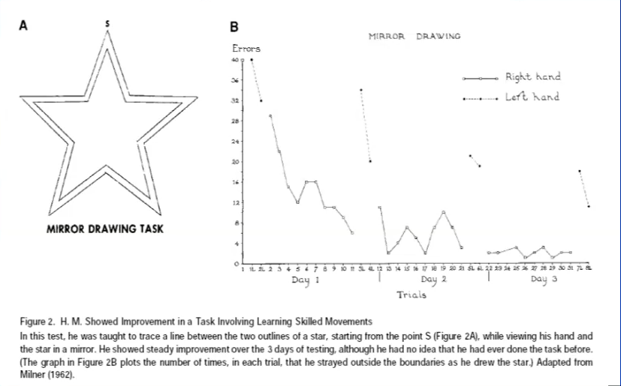One of the things they did was had HM complete a mirror drawing task. In this task you can’t see your own hand and you must trace a star in the mirror with everything reversed. It's difficult to do, and you must learn how to do it. What you see (in the above image) is HM’s performance on day one, day two, and day 3. Specifically, we can see the number of errors he made on his right hand. A lot of these errors were on the first day, some errors were made on the second day, and almost no errors were made on the third day. His tracings also improved with his left hand. The research assistant would come into his room and say it’s time for the testing. He would be surprised on day two that he had to complete this task. He didn't remember that they had tested on day one the same thing on day two. In other words, it was a brand-new experience. He had no idea that he had done it before, but he still demonstrated improvement. It shows the dissociation of these processes.
Traditional concepts and psychoanalysis focus on psychosexual development. For example, the pre oedipal period, dyadic (mother-child interactions), and other child interactions versus oedipal period with mother, father, and the child (three person phases of development). In object relations we have the development and differentiation of internal member representations of self and others which is the determinant of overt behavior. An illustration of what I was talking about before in terms of what's inside the head is the determinative of the external behavior. External behaviors less significant than what's in the head. Separation and individuation, the capacity for autonomy has to do with Margaret Mahler's work. Attachment styles secure and insecure, these are accepted perspectives within psychoanalysis. These concepts have been informed by research on mother - child interactions and child development research. How might we ring a neuroscientific understanding into this? Well, there's a distinction between model - free and model - based learning. Very young children learn what to do based on what feels good and what doesn't. This is model-free. These patterns get deeply ingrained via statistical learning. Attachment experiences, especially early ones, are learned habits more commonly than intentionally chosen behaviors. This has implications for interpretation and adults of unconscious motivation. We're dealing with an abstraction superimposed on implicit process, it's model-based rather than model-free learning. Deficits lack of development they contribute to ongoing difficulties and lack of resolution of conflict. This is what I mean about model - free versus model - based learning. This is in the reinforcement learning tradition. 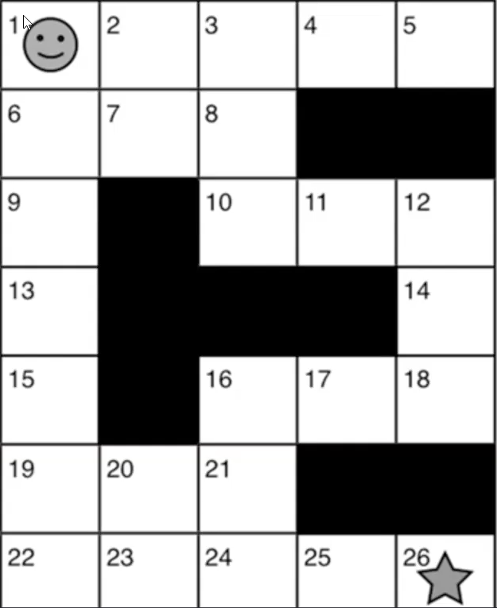. We start at square one at the top, and your goal is to get to number 26. When you look at this you'd say, well, what's the best way to get from one to 26. You could tell that it's going straight down and going across right. That is a model-based view of the problem, because you understand the whole situation, and you reason what's the best strategy. What about model – free? This is what’s happening with children. There are no outcome predictions. You just store and update average reward values for state action pairs. You pick the action with the highest reward average. I feel like acting like this, but I don't know why. Does the child want to go to mother for comforting or not? How did it feel last time? They're not thinking it through such as, ‘Oh, it would be a good idea to please mother.’ It's what feels right. You're at the square, what is the value of going this way or that way? It's a different way of learning and decision making. It's computationally much simpler. Okay. let me now relate this to the problem of recurrent maladaptive patterns, and this is taken from Ryan Smith’s chapter on Computational Mechanisms.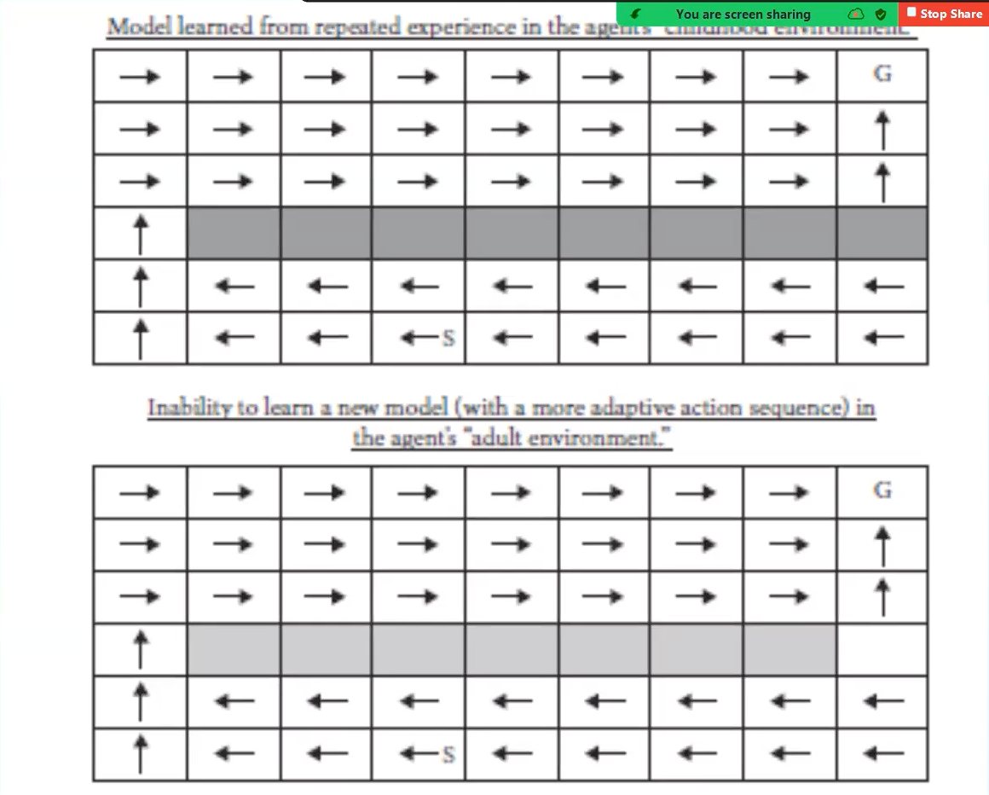 I want to call your attention to this square here, right? This is a model learned from experience in the childhood environment. So, you're starting here, and your goal is to get up here, right? What you've learned growing up is that this route is not possible. You have to kind of go around in a circuitous manner to reach your goal. There's a challenge when you're an adult. To what extent can you learn a new model in the adult environment. You're starting here, and this is your goal, and low and behold, this pathway is not blocked, so it's a much shorter route to your goal. The key point is that if feel your way around and respond to the environment randomly, you are not going to spontaneously find this route, and I think that's where psychotherapy and the psychotherapists really help. They point to things that you can do, that you don't know to do or wouldn't otherwise know to do. You’re encouraged to try them out and you wouldn't be inclined to do it because it might induce intolerable affect. You deal with that.
Okay. Conflicts and traditional concepts. Forbidden sexual and aggressive impulses conflict with societal and personal standards. Conflicts can occur between drives, and between mental agencies or between wishes and reality. Conflict between pleasure principle, and death instinct. I think that would not sell too well with practitioners from other perspectives. Mental agencies, agencies in ego super ego. You can't really practice psychoanalysis nowadays without these models. On the other hand, Freud, said these are temporary solutions. Conflict between wishes and reality become more tangible. A common issue is that building conflicting impulses, for example, loving and murderous impulses toward a parent, or their attachment figure as in the oedipal conflict. Conflict is unconscious, and gets expressed in maladaptive behavior, such as an inability to maintain a close relationship or guilt interfering with occupational success. Conflict, generally, is a biological imperative for the species so that we need to survive as an individual, and we also need to reproduce. We have an inherent dual nature as both individuals and social creatures. We're extremely social creatures, but we're also individuals as well. As individuals we compete, as social creatures we cooperate. It's hard to succeed without both and these goals often conflict. Sid Blatt was a professor at Yale for many years and developed a theory of personality development involving two main goals: Development of self, self, definition and self-actualization, and attachment and intimacy. These are two separate development lines that interact. You want to ideally do both. Inherently, conflicting behavioral trends get reconciled using both model-free and model-based learning. It's a lifelong undertaking to figure out how to achieve of your own and maintain relationships.
What about defenses? Classic, unconscious defenses described by Anna Freud include repression, projection, reaction, information, isolation of affect and more primitive defenses. For example, borderline personality disorder involves splitting projective identification and dissociation. Charles Brenner, a classic psychoanalyst from New York, pointed out in a book written in the 70s, any thought or behavior can be a defensive function that is avoiding the stress or awareness of conflict. It raises a very technical issue about how you do your psychotherapy. Traditionally it was thought that you must address defense before content in psychoanalysis. It leads to a cautious approach to affect, as potentially dangerous and overwhelming. We can think of defenses more broadly as a subcategory of avoidance behaviors in general. Avoidance of distress is a universal goal. It's widely accepted in other psychotherapy modalities. It is very important in etiology and treatment. In trauma we learn to avoid certain people, actions, or thoughts to minimize the stress for it to never happened again. which is the basis for recurrent patterns. Avoidance is often achieved by active reversal and passive experience. For example, I’m not weak and vulnerable, I am strong and independent. Since emotion is typically not being repressed, only address, defense, or avoidance, if needed. In emotion focused psychotherapy, for example, Less Greenberg doesn't even talk about defense, and he's very effective at eliciting emotions for the purpose of transforming emotions and changing maladaptive patterns without first interpreting defense. I think that's informative, and it's very contrary to traditional psychodynamic thinking. Psychoanalysis would benefit from incorporation of more emotion focused techniques.
Traditionally, we try to make the unconscious, conscious. It's psychodynamic. There are motivations that we're not aware of, and that are driving maladaptive behavior. We want to bring them into conscious awareness. We want to promote insight and understanding and it's typically working at the conceptual level to change patterns that are in fact implicit and relational. We've talked about these recurrent patterns. They operate implicitly, and we work within the transfers to modify the recurrent pattern. Daniel Stern talked about critical moments when something positive and unexpected happens in the therapeutic interaction that promotes change. This can be thought of as a prediction error or updating a prior set of expectations. We're now moving into the domain of computational neuroscience now. I'm going to introduce this by saying what made video streaming possible. Well, of course we needed the Internet, but it was also the discovery about how to stream in a computationally more efficient manner. How is psychoanalysis like video streaming? The answer has to do with this equation: prior plus prediction error equals posterior. How does this relate to streaming? When you're watching a movie or something it’s 24 frames per second. Think about digitizing that. You must completely digitize that entire frame but the next frame, 24 frames a second is very, very similar to the first one, but it differs a little bit. You could think of the first frame as your prediction, and then they discovered that all you need to do is encode what's different about frame 2 compared to frame one to get frame 2 and then you do that same thing with frame 3 compared to frame 2. It's much less computationally intensive, it goes much faster, and low and behold we really believe this is how the brain works. We're constantly making predictions and passing error messages, and the whole issue is, are you sticking with your prior, or are you updating your prior with prediction, error, and creating a new posterior?
Can this framework be used to understand how the mind brain changes. Predictive processing, perception based on predictions is ubiquitous. We gave the example of the woman kissing the horse as predicted processing. Transference really amounts to expectations and Priors. A combination of beliefs and expectations which then generalize from these situational conceptualizations. Corrective emotional experiences are prediction errors. You're expecting to be judged and rejected. In fact, you're treated in a non-Judgmental, empathic, compassionate manner. Change involves updating priors and resistance is difficulty in updating the priors for good reason. We will see the therapeutic Alliance through model-free learning. Can create newly implicit patterns of relating which is the foundation for change. Talked about the difference between experiencing versus understanding. Experience alone, model-free learning. or the combination of model free and model-based learning with interpretation will work but based on the arguments I've been putting forward, understanding alone can't easily overcome years of model – free, habit learning. Now we're going to talk about the intimate relation between perception and action in computational neuroscience. As well as perception response to the predictive coding aspect, and about action it's active inference. So, perceptions are based on predictions which are based on prior knowledge. Perceptions are also influenced by the action options available. So perceptual content itself is strongly influenced by the personal consequences of the action options available. Think about someone who’s a little bit socially anxious or phobic and they look at a social gathering, and they perceive it a certain way as dangerous. The actions available to them will influence how they receive it.
On the active inference side, the actions we take influence what we perceive. As we'll talk about, we try to minimize prediction error, so that you can choose what you're exposed to to minimize the likelihood of inducing prediction error. The actions selected or influenced by the anticipated sensory consequences of the action. The action can be not just a motor action or behavioral action but can be a cognitive act. The sensory consequences can be interceptive, internal, or emotional, not just exteroceptive. What that means is that we automatically consider what are the consequences of an action before we take it, and if an action is likely to lead to distressing emotions, we might avoid it. We get an approach that's relevant to staying stuck in recurrent patterns. This has implications for repression and repetition. The fundamental principle of brain function is that the mind-brain seeks to minimize prediction error. We want our environments to be predictable, so we can enjoy ourselves and stay on an even keel emotionally. This may explain repression. Going back to the example that I gave at the Freud Museum last week. We unconsciously anticipate the negative emotion that would be induced by a thought, and therefore don't automatically select that thought. We steer away from it without knowing that we do. This may also explain repetition. We tend to choose actions, including situation selection. or situation creation, and our relationships that minimize prediction error. Repeating a known bad situation, avoids prediction error which is consistent with this fundamental principle of brain function. The negative emotional consequences are known and not surprising, they don't produce prediction error. Maintaining the internal working model as is leads to repetition, and the same old story. Credit to Angus, who developed the narrative emotion process coding system where she uses that language, and also contract change. Updating priors requires increasing the precision with salience of the prediction error about recurrent maladaptive patterns. The prediction error is the hidden feeling or intolerable emotion which is exposed when defenses fail. When defense prevail the precision or salience of the prediction error is low, preventing updating of the prior. Therefore, experiencing and transforming intolerable emotion may be the best way to update the model, and alter predictions, expectations, and change action, options which are linked to anticipated distress, and thus prevent repetition. In other words. if we're changing the anticipated emotional consequences of an action then you're more likely to engage in different kinds of actions and not be stuck.
I want to return to Freud's repetition compulsion, and his further theoretical development where he linked the death instinct. Up to 1920, he'd been following the pleasure principle and trying to explain behavior on that basis. There are four examples of things that he observed. Recurring dreams about trauma. He observed these things that aren't consistent with pleasure, the attainment of pleasure. A child repeatedly throws a favorite toy away, it gets upset and reels back in. Patience and analysis who unknowingly repeat unpleasant experiences rather than remember them. We get the example of being defiant and critical with parents, and now with doctors. Finally, what’s called the fate neurosis, repeatedly experiencing a repeated pattern of misfortune in life. Some people find themselves betrayed by friends. Sometime later, they are betrayed again and again. Freud couldn't explain that based on the pleasure principle and came to explain it based on the death instinct. In 1920, World War I obviously had a devastating effect on the world and ended in 1918. The death instinct, an innate and unconscious tendency towards self-destruction, postulated to explain aggressive and destructive behavior not satisfactorily explained by the pleasure principle. Freud believed that humans are driven toward death and destruction. If the aim of all life is death, there's no use in trying to get rid of man's aggressive inclinations, at best they can be merely diverted. There was this analysis that was done of the Cold War, and basically every action done by the United States or the Soviet Union can be explained as a matter of security and need for protection. In other words, attachment to loved ones and their protection was the origin of the aggressive actions in that situation. Oxytocin is not just a love hormone. Oxytocin triggers feelings of love and protection but also promotes the feeling of bias and coordinated strategic action toward people in an out group. Those who are perceived as different from the group you're in, the in group, with whom you heavily identify. In other words, it promotes not just love, but also, protective action, and maybe even hostility. Oxytocin is now thought to increase attention to the salience of both positive and negative social queues. This is another way of understanding aggression between groups.
Now there's some have slightly heavy-duty theory that I’m going to try to make as simple as possible, and I'm probably oversimplifying it. I'm about to say some things that hopefully are correct. I can't guarantee. Prediction errors are an example of expected free energy. Free energy is a mathematical principle of information physics. Free energy is entropy or randomness. Living systems minimize entropy or expected free energy to optimize their adaptation to the world. Aging and death occur due to breakdown and failure regulatory systems. Death is not the aim of life. That's our current understanding, a century later. Similarly, we try to update our internal working model of the social world to optimize, predictability and adaptation. There are two mathematical terms that determine which actions have the highest value or the lowest expected free energy. The first term is instrumental, and the second term is epistemic. So instrumental we try to maximize current positive emotion by minimizing the deviation between expected and preferred outcomes. To repeat, we maximize the current positive emotion by minimizing the deviation between expected and preferred outcome. For example, if you've had early life trauma and you expect things to be very bad, your least bad option is preferred. That's minimizing the difference. For epistemic, you maximize information gain which increases confidence in which future actions will lead to preferred outcomes later. It's a kind of balancing of these two. If you try new things that may become dangerous and decrease your positive emotion. I think therapeutically, the therapist encourages new actions to broaden horizons, find new pathways to achieving your goal. Revisiting the pleasure principle and death instinct considering computational neuroscience. Positive emotion, and the pleasure principle does factor into action selection. Minimizing expected free energy and avoiding entropy links to fundamental forces that maintain life and prevent death. Freud was on to something a century ago when he tried to explain the motivational basis of human actions in terms of pleasure and life and death issues.
To conclude, recurrent maladaptive patterns are foundational in psychoanalysis and psychodynamic psychotherapy. There are patterns of behavior that aim to avoid intolerable distress, they are what we're trying to treat. These patterns are ubiquitous but are not recognized by other psychotherapy modalities as important targets of intervention. Psycho analysis and psychodynamic psychotherapy, therefore, have something very substantial to offer. Survival of these modalities is threatened by a precede lack of scientific rigor. Reconceptualizing fundamental concepts and more empirically tractable terms will promote understanding across modalities and enable a realization of Freud dream to understand the mind based on an understanding of the brain. Computational neuroscience is the leading model for understanding how the brain processes information. Understanding the mind based on fundamental principles of brain function increases the likelihood that newer psychological conceptualizations will have enduring value. Recurrent patterns in their treatment can be reconceptualized in these terms. Putting psychoanalysis and psychodynamic psychotherapy on a stronger and empirical footing may ensure their survival and potentially reinvigorate their standing in the mental health field. I want to acknowledge these seven people who read the chapter and critiqued it for me. Lynn Nadel, and Ryan Smith, neuroscientists, Mark Solms, Paul Wachtel, Claudia Subic Wrana, psychoanalysts, Hanna Levenson, who does psychodynamic therapy and integrates emotions with psychodynamics to my mind better than anyone. Finally, Karen Weiss, my wife, a Professor of Psychiatry, with me at the University of Arizona, who is the first person to hear about my new ideas, and she always gives me good feedback. Her enthusiasm tells me a lot, or lack thereof, and things that need clarification she helps me sort out. Thank you very much, that concludes the lecture.

.

