Lecture 5: Unconscious (embodied) emotion and the neural basis of emotional experience.

Today’s lecture is going to focus on neural models of emotional experience. I am going to start off with some introductory material about the central importance of emotional experience in psychoanalysis and generally, in life. Then I’m going to present two different models. The first one is drive and defense and the theory of basic emotions. In the context of this model the failure to experience emotion, or the non-experience of emotion is due to active inhibition (i.e., defenses particularly repression). In this other model, emotional experiences are conceptualized as learned constructions. Explaining that when emotion is not experienced, it may be due to deficits and skill acquisition. I'm going to try to bring in Freud whenever possible. I am going to certainly talk about Freud psychoanalytic writings in support of the first model. And this, by the way, is the predominant model in psychoanalysis today. I am also going to bring in Freud’s pre psychoanalytic writing on Agnosia in particular, and how it supports the second model. I want to do a little thought experiment with you about the importance of emotion. I want you to imagine that you could have any of the following things, or all of the following things: You could have as much money as you could possibly want; you could have the home of your dreams; you could have your dream job or if you didn't want to work; you didn’t have to work at all; you could have the romantic relationship that you've always dreamed of; you could also have the happy family experience you might have always longed for. You could have all that only under one condition. You couldn't experience emotion. Would you accept that deal? Most people would not accept the deal. The point is that emotions are important.
I want to situate emotion within the whole context of memory reconsolidation and schemas that I've been talking about so far. I want to quote Mark Solms in a 2020 paper. Mark Solms is the person who founded the field of neuropsychological analysis. In this paper he talked about core claims about the emotional mind that are the basis for doing psychoanalysis as a natural science. The whole purpose of this course and this fellowship is trying to put psychoanalysis on a stronger empirical footing. He says that there are three testable and falsifiable claims about the emotional mind that basically make psychoanalysis a natural science. First, the human infant is born with a set of innate needs and is not a blank slate. Secondly, mental development involves creating the capacities to meet these needs in the world. And third, most of the ways that humans learn to meet their needs are implemented unconsciously. These are testable and classifiable clients, and this is how the basic science of psychoanalysis can develop. Memories and schemas include the learning that individuals must do to know how best to meet their needs, and the internal working model that we've talked about constitutes the scaffold or framework for meeting emotional needs in one's unique environment. It really puts emotions and emotional experiences at the center of this and how to meet your needs and have the best life possible.
Emotions are playing a central role in recurrent maladaptive patterns, which is what we're aiming to treat, and they play a central role in the treatment. Recurrent male adaptive patterns arise to avoid the experience of intolerable emotions, while still meeting needs as well as possible. I have argued previously, and will continue to make the case, that the corrective emotional experiences are necessary to transform those patterns, so that the relevant emotions become tolerable, usable, and allow for more adaptive functioning. Whereas insight is helpful but not essential. Clearly interference, with the ability to experience emotions, is of central importance. I'm now going to show you a cartoon that kind of introduces the topic and indicates it's complexity. 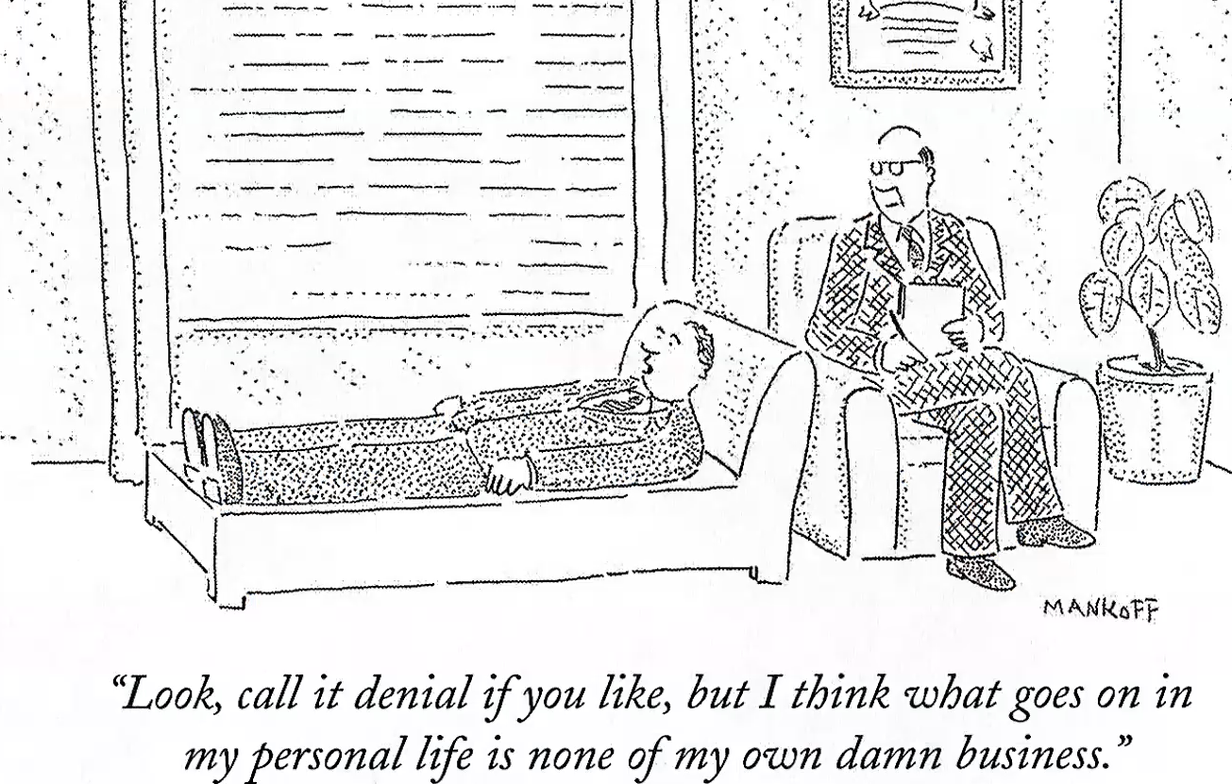

Now let us focus on a case that is not a laughing matter. This is an actual case that illustrates the complexities of trying to understand why it is that people don't experience emotion when you really expect them to. This is a patient who we saw when I was running the psychiatric consultation Liasson service at the University Hospital in Tucson. A 41-year-old unmarried woman was hospitalized for work up of abdominal pain. Abdominal ultrasound and endoscopy were negative. They couldn't find a medical explanation for the abdominal pain, so a psychiatric consultation was requested. The patient reported that persistent pain had been present for 3 months. We asked her, did anything happen around 3months ago that might be related to your pain? She said no. Then we continue to take a history of psychosocial history, and we learn that her mother had just died 3 months previously. We said, we asked you about if anything had happened related to your pain, and your mother died. You didn't mention that. She responded by saying, I don't think that has anything to do with my pain, so I didn't mention it. It turned out that this was her adoptive mother who took her in at the age of 8. They had been together for over 30 years. Her biological parents were alcohol dependent and physically abusive, so she had a lot of life trauma. She was placed in a series of foster homes until she was adopted by this woman. This woman was a very kind and nurturing person, and she suffered from diabetes and peripheral vascular disease. During the last 5 years of the mother's life, the patient cared for her daily. Clearly, they were very close. One week before her death, after a medical setback, the patient contemplated the possibility of her mother's death and was overwhelmed with the feeling of grief. A week later the mother died of a G. I. vascular obstruction. Since her mother's death, the patient has experienced no feelings of grief or sadness of any kind. What she has is abdominal pain. In addition to pain, she suffered from anhedonia, lack of the ability to experience pleasure. She didn’t have any vegetative symptoms of depression but met criteria for major depressive disorder. Why did this patient not experience grief? Let’s rule some out. Is it possible that she is not manifesting grief because she's just not grief stricken at all? In other words, she's just having a weak response, and there's nothing to react to. That seems unlikely given that she was overwhelmed with grief the week before, and that they were so close good. One might even say that in this case the mother was the only secure attachment she had in her life. Another possibility is that she's having a strong response that's experienced in a differentiated manner. She's grieving but is not putting into words the grief she has. She says that she has no grief or sadness, but maybe she's experiencing it and not able to talk about it. The experience can be mentally represented and verbalized as grief, but it's unwanted and excluded from consciousness due to the defenses. Basically, she's repressing her grief which seems like a very reasonable explanation. Here's another way of thinking about it. She has a strong emotional response that is not experienced, differentiated, or mentally represented, because the state response is too strong. Or this is a trait characteristic of the individual in the sense that people with early adversity sometimes are quite impaired in their ability to experience and describe their emotions. However, if that were true, that would be true across the board, and that's not true for her, because we know a week before, she had overwhelming grief. The third possibility is that it's a state trait interaction. This means this individual has a low tolerance for experiencing emotional distress because of her early adversity, and because of this experience, the stress is so strong it isn't mentally represented or experienced. However, it is experienced in the body because emotion start in the body.
That is the alternative explanation, and the rest of this lecture is about these two alternative models. Breuer and Freud psychoanalysis started in 1895, with studies on hysteria. They designed what might be called the “Strangulated Affect” hypothesis, the conversion of affect into bodily symptoms. Affect that was activated during the traumatic event could not be expressed at the time of the trauma. This fits the case that I've presented. The patient’s mother died, affect could not be expressed, and the grief could not be expressed. Symptoms (the abdominal pain) resulted from this failure to express the emotions associated with the event. The unexpressed emotions prevented the memory of the trauma from dissipating, and the strangulated effect was expressed indirectly in semantic symptoms that represented which had been repressed. The mother had a GI vascular obstruction and this patient had abdominal pain. Maybe this is representing the loss of the mother. The point is that this is an explanation from 1895. In some ways this kind of fits the clinical material. I want to go back to the first lecture talking about how mechanisms make a difference, even though phenomenologically, it may seem to be the same. It's the sun setting in the West and the earth, rotating away from the sun.
I am now going to tell you about Freud's writings on affect. Throughout his career Freud only addressed mental contents that had been previously known or represented. This is an important point, because I am going to make the case that there's such a thing as emotions that are not mentally represented, and therefore not experienced as emotions. His writings were not comprehensive, systematic, or internally consistent, and that's understandable, because not that much was known about emotions a century ago. We can describe 3 different phases of his writing on affect. The original idea was that affect was a quantifiable substance. There was a hydraulic model, such that affect was the conscious manifestation of instinct, and pleasure was experienced when the instinct was discharged and satisfied. However, a buildup of the instinct could lead to displeasure. Another idea was that affect was a kind of safety valve. For example, if the child is hungry or helpless that could lead to a kind of fantasy or hallucination of the breast, which essentially the affect is attaching to a wish. The third idea is affect as information. It is the signal theory of affect in the 1920s, where affects signals impending danger to the ego in the context of unconscious conflict which then mobilizes defenses. These are some of the ideas that he had.
There is this very important question about unconscious emotion, because, in the example of the case that I gave, it seems like there's grief that's unconscious. How did Freud conceptualize that? Here are some quotes from Unconscious (1915). Freud says, “it is surely of the essence of an emotion that we should be aware of it, i.e., that it should become known to consciousness. Thus the possibility of the attribute of unconsciousness would be completely excluded, as far as emotions, feelings, and affects are concerned.” Because it was thought that the essence of an emotion was experience. However, he says, “But in psycho analytic practice we're accustomed to speaking of unconscious love or hate or anger and find it impossible to avoid even the strange conjunction, such as unconscious consciousness of guilt, or a paradoxical, unconscious anxiety. In every instance where repression has succeeded in inhibiting the development of affects, we turn those affects unconscious. Which we restore when we undo the work of repression. Thus, it cannot be denied that the use of the terms in question consistent; but in comparison with unconscious ideas there is the important difference that unconscious ideas continue to exist after repression as actual structures in the system unconscious. Whereas all that corresponds in that system to unconscious affects is a potential beginning which is prevented from developing. Strictly speaking then, although no fault can be found in the linguistic usage, there are no unconscious affects as there are unconscious ideas, but there may very well be in this system unconscious, affective structures. In the present state of our knowledge of affects and emotions. We cannot express this difference more clearly.” Eight years later in 1923, Freud says, “We then come to speak in a condensed and not entirely correct manner, of ‘unconscious feelings’, keeping up an analogy with unconscious ideas which is not altogether justifiable. The difference is that whereas with unconscious ideas connecting links must be created before they can be brought into the conscious system, but with feelings which are themselves transmitted directly, this does not occur. In other words, the distinction between conscious and pre-conscious has no meaning where feelings are concerned. The pre-conscious here drops out, and feelings are either conscious or unconscious.”
Here are some conclusions. Freud viewed emotion as an expression of instinct that sought discharge and needed to be controlled through defenses. Unlike thoughts, emotions did not involve any kind of preconscious processing. They viewed emotion and ideas as totally separate entities. He also viewed emotion as either conscious or not manifest. Unconscious emotions when they occurred are due to repression. He did not have a concept of emotion as adaptive, or as an expression of a drive to attach to other people, as we understand emotion to do today. We now know that emotions enable connection, interaction, and communication. Similarly, we now view genes as highly regulated by interaction with the environment, not autonomous blueprints for biological processes, independent of life circumstances as they might have originally been thought to be. In other words, there's a change in our understanding of drives and in our understanding of genes.
This brings us to Charles Darwin and his book in 1872, on “The Expression of the Emotions in Man and Animals.” Obviously, he's talking about natural selection and the descent of man from apes and other animals. What Darwin and others following him have pointed out is the correspondence in emotional expressions 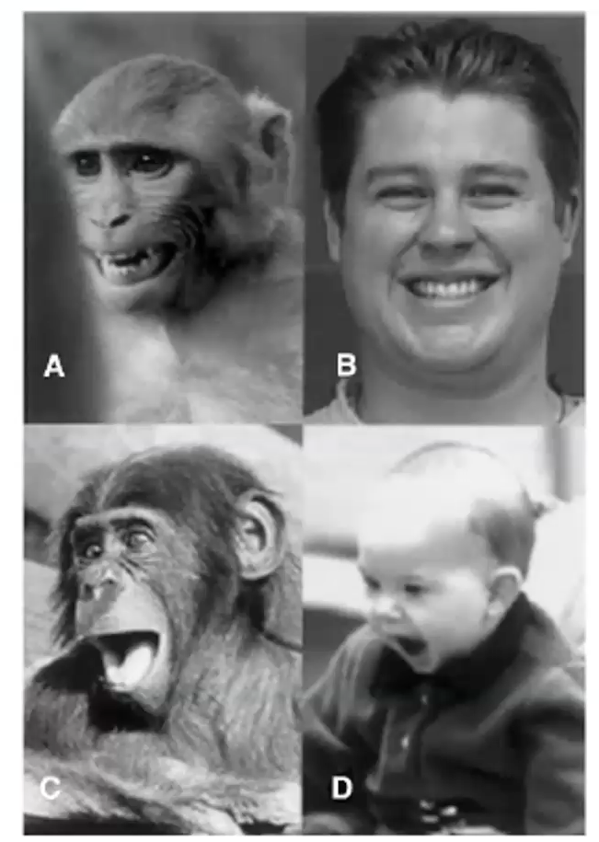
You see the ape on the left side and the human on the right. There’s a lot more history that could be brought in but I’m cutting to the chase here to highlight this kind of drive and defense model that is most popular within psychoanalysis and neuro psychoanalysis today. Basically there's 7 basic emotional systems involving: seeking, rage, fear, lust, care, panic, and play. There are key brain areas associated with each of these systems and their key neural modulators and neurotransmitters associated with each. Now, a foundational idea here is that when subcortical structures are activated in the case of each system, emotion is necessarily experienced. This is closely related to Jaat Panksepp’s lifelong career studying emotional systems and animals. He has a strong conviction that animals are feeling emotion. According to the system if emotion is activated, experience is activated, and for emotion not to be activated, it must be defended against. Jaat Panksepp quoted some neuroimaging work by Antonio Damasio.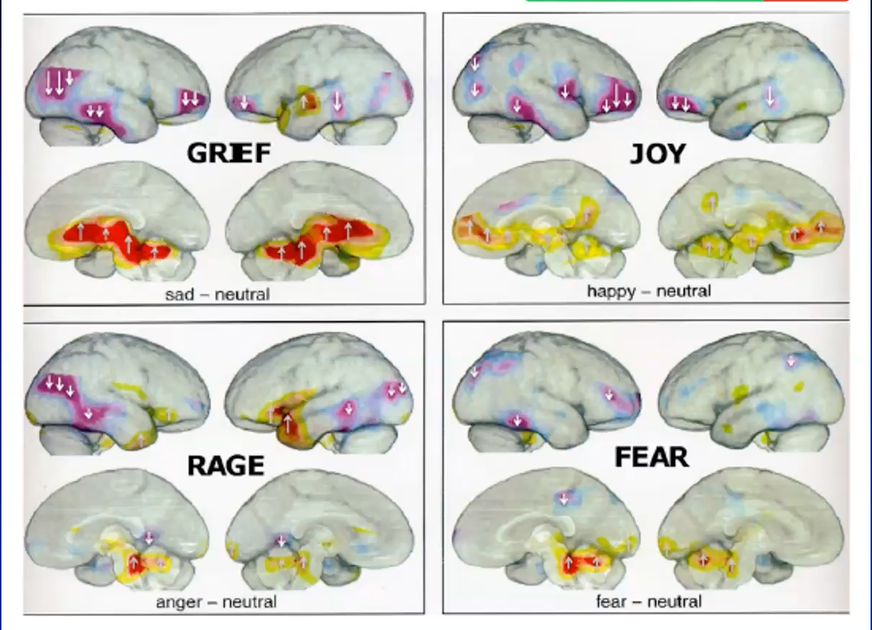 This is from a study in the year 2000 where they had people recall personal experiences. If you see here in the upper left, he calls grief, upper right joy, lower left rage, lower right fear. Each category has a unique pattern of activity. That is evidence in support of discrete kinds of emotions. If you look at the pattern of activity, you'll see that a lot of the same structures are activated to various degrees. The amount of activity in these regions may differ, but from an alternative perspective, similar structures are activated to varying degrees in these different emotions.
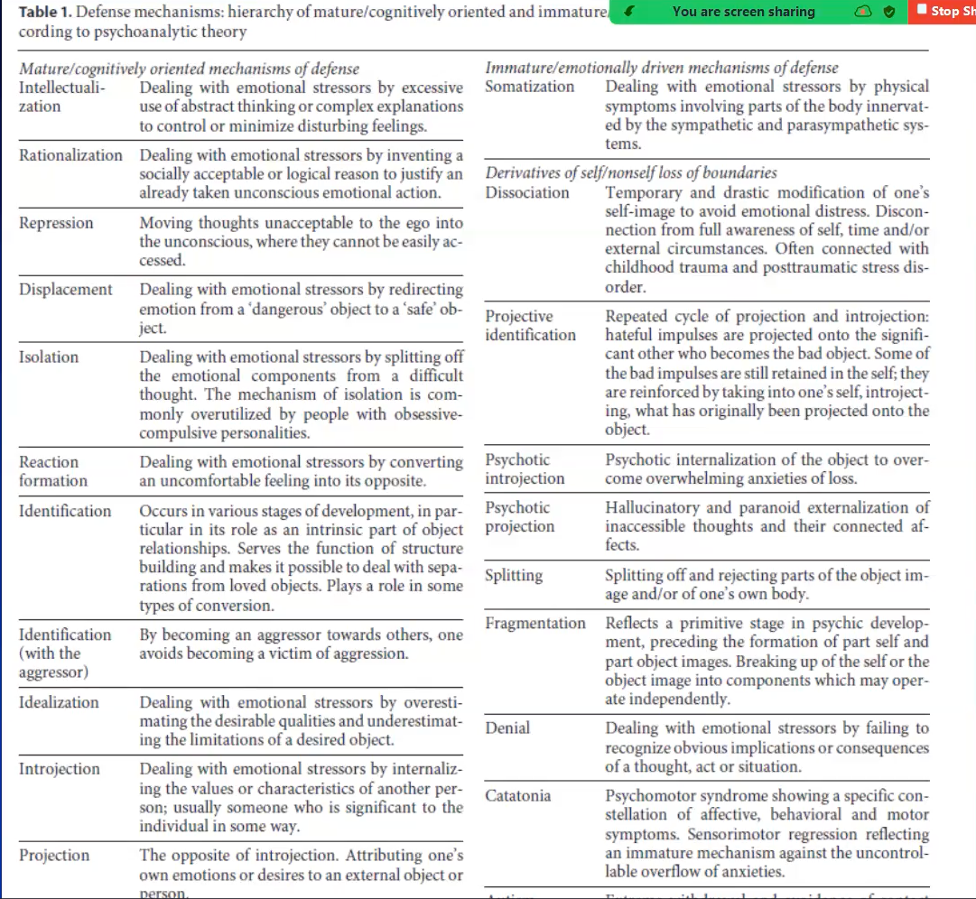
A few words on defenses. Broadly speaking we can categorize defenses as more mature versus less mature. More mature may be described as more cognitively oriented, and the more immature, more driven by emotion. For example, intellectualization is dealing with emotional stressors by excessive use of abstract thinking or complex explanations to control or minimize disturbing feelings. Somatization, defense dealing with emotional stressors by physical symptoms involving parts of the body innervated by the sympathetic and parasympathetic system. In other words, the patient I presented had abdominal pain by virtue of the defense of somatization. Splitting, commonly seen in borderline personality disorder, where splitting off and rejecting parts of the object image, or one's own body. Idealization, or devaluation of a person is either all good or all bad. Denial, dealing with emotional stressors by failing to recognize obvious implications or consequences of a thought, act, or situation. To illustrate the emphasis that's put-on defense in psychoanalysis relative to emotional experience, I was really struck by this passage from a popular textbook of Psychodynamic psychiatry by Glenn Gabbard. In this chapter he's talking about doing an initial assessment, and under the category of affect, he says, “Observations about the patient's emotional states provide a goal line of information about defense mechanisms. After all, the management of affect is perhaps the most important function of defenses. Patients who describe extraordinarily painful events in their lives without being moved in the least, may be employing intellectualization. Hypomanic patients who assert that they always are in a good mood, and are unusually jocular with the examiner, maybe using denial to defend against feelings such as grief and anger. Borderline patients who express contempt and hostility toward the key figures in their lives may be employing, splitting to ward off any integration of good and bad feelings.” This is how you evaluate affect, you evaluate defense. This is part of the reason why I think there's value in considering an alternative perspective. We think about defenses but the flip side of it is that we can also look at what people are able to report about what they consciously experience. They're not necessarily the same.
Going back to basics. Now a century later, here is my definition if you will, about what emotion is. My background is that I am a fully trained psychiatrist that tenured, went back to get a Ph. D. in cognitive neuroscience, with an emphasis on emotion. I have thought a lot about this. Emotion consists of automatic assessments and adaptive responses to important recurring situations. The function of emotions is enhancing adaptation to the environment by learning from experience and interaction with it. And this is most evident and prominent in mammals. Regarding automatic assessments, there's an automatic, typically unconscious assessment going on all the time about whether needs, goals, and values are being met in interaction with the environment. We're not aware of that, but we're constantly doing that. Our amygdala and other structures are on while we are awake. That automatic assessment triggers emotional responses. The emotional responses are multi systemic. It involves an automatic resetting of physiology, behavior, thought and perhaps feeling. If something happens, you are very frightened. Your heart rate increases to provide metabolic support for the behavior of avoidance. If you are frightened, you become more alert. There is also this feeling component. However, I want to emphasize that that is not an essential obligatory component of the emotional response. You can have a bodily response without the feeling. In any case, these emotional responses enable higher organisms to rapidly adapt to changing circumstances. To broadly introduce the idea of the ability to experience emotion as a construction, and as an acquired skill, I think it's useful to think of individuals varying in the degree to which they have a small or larger repertoire of emotional concepts available to them. Clinically, we see, that some people are very limited in their ability to describe emotions. They might just be able to say good or bad, not much more to say than that. We use the metaphor of the Crayola box. Is it a very small one, is it medium size, or what is it quite large as might be the case for people who are used to talking about emotions and expressing how they feel. The next lecture is going to be all about emotional awareness and how to understand where these differences come from.
I want to tell you the story of how this deficit view of emotional impairment arose as distinct from the defense view. In the twentieth century it was recognized that interference with the experience or expression of emotion states is pathogenic. Franz Alexander, a psychoanalyst, founded the Chicago Institute for psychoanalysis and was trained in psychoanalysis in Berlin. He is also the person who coined the term “corrective emotional experience.” He talked about 7 different psychosomatic disorders that he thought were due to different kinds of emotional conflicts. He called it specificity theory. For example, there was a specific unconscious conflict associated with hypertension. People with hypertension seek to control the expression of hostile and aggressive feelings to avoid losing the attention of others and tend to be overly compliant. Also, people with peptic ulcer have the wish for nurture and support which is renounced to promote independence and self-assertion. He thought that all core conflicts were associated with repression of emotion consistent with the Freudian model. That was 1950.
20 years later there were these two psychoanalysts at Harvard, Peter Sifneos, and John Nemiah. They were interested in testing specificity theory. They recruited patients with these different medical disorders, and they interviewed them. They were looking to see if this is really the case that they have these different kinds of conflict. They were surprised with what they observed. They did not find evidence for these different unconscious conflicts, as a matter of fact, there seemed to be a problem with emotion in these patients. As they said, these patients manifested either a total unawareness of feelings, or an almost complete incapacity to put into words what they were experiencing. Think about the patient that I presented to you before. For 3 months she had no sadness or grief whatsoever. She was manifesting either a total unawareness of feelings or some kind of complete incapacity to put them towards what she was experiencing. People who have defenses might have more intermittent waves of grief, for example, coming and going. This was pervasive. They coined the term Alexithymia from the Greek, “lacking words for emotion.” That's Peter Sifneos from Greece. He coined the term in 1972 and in 1976, they had a consensus conference in Heidelberg on Alexithymia and there was this consensus definition about what alexithymia was. It involved difficulty identifying feelings, difficulty describing feelings, externally oriented thinking, because people weren't, very introspective, and a fundamental impairment and symbolization capacity which interfered with dreaming, daydreaming, and fantasy. Importantly, alexithymia is considered a deficit, not a defense.
Now in 1948, years, 25 years earlier, Jurgen Ruesch really captured the essence of this in a paper in psychosomatic medicine. The papers entitled, “The infantile Personality: The core problem of Psychosomatic Medicine.” The deficit or developmental arrest, and the capacity for symbolic mental representation of emotion was the core problem in patients with psychosomatic disorders. Tension must be expressed through action or through organs. It is through visceromotor processes or psychosomatic processes. That was in 1948. I am highlighting the years because this consensus definition of alexithymia became the basis for the Toronto Alexithymia scale that’s dominated research on alexithymia for recent decades. But I want to point out that in 1978, the concept of theory of mind was put forward for the first time. This came after alexithymia was defined. I'm going to try to make the case that the theory of mind is very relevant to this whole idea about constructed emotion and the ability to know what it is that you're feeling.
So, I’m going to illustrate to you a theory of mind task. It's called the Sally Anne task, you can do it with little children. 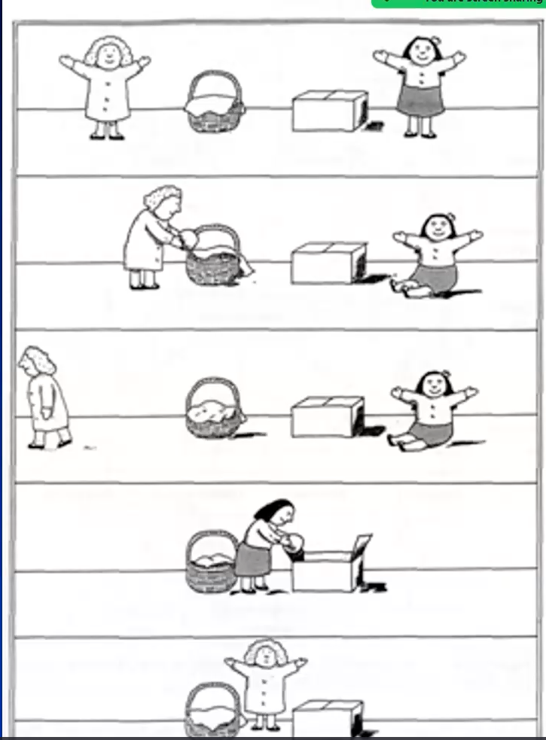

You have Sally on the left, and you have Anne on the right. Sally has this object in her hand, that's a marble apparently. She puts it in the basket, and she leaves. Anne gets the marble, puts it in the box. Sally comes back. What does Anne say about what Sally thinks about where the marble is? Does she recognize that Sally's belief is different from the knowledge that she has? It's a false belief task. Children, as young as 4 or 5 years old can successfully do this. Kids in the autism spectrum are impaired in this. We now know that this concept of theory of mind is very foundational. It's the ability to recognize that another person has a mind. That same function involves the ability to know what another person is thinking, what another person is feeling, and what you yourself are thinking, and what you yourself are feeling. The medial prefrontal cortex area is very involved in that. The argument is that this involves creating a mental representation of the mental state.
There is additional research to try to make the connection between theory of mind function, its impairment, and compromised experience. This is a meta-analysis of twelve functional neuro imaging studies where various kinds of tasks were presented, emotionally, cognitively, or both. Heart rate variability was measured simultaneously. Heart rate variability is a measure of vagal tone, or the inhibitory function on the heart. The vagal nerve slows the heart down. Conversely. when heart rate variability is low, that's when you're aroused. So, the finding is that there's a strong positive correlation between heart rate variability and activity in the medial prefrontal areas. What does that mean? When you are calm and relaxed, heart rate variability is high, and engagement of this region is high. When you're calm and relaxed, you can reflect about things. Conversely, that same positive correlation means that when our variability is low, and you are highly aroused, the medial prefrontal cortex goes offline. That ability to represent mental states goes offline and is impaired. I think this is what was happening in the patient who I presented who was overwhelmed with such a strong feeling of grief. The arousal was so high that her medial prefrontal cortex went offline. Resulting in what I would call a type of unconscious emotion.
“Unconscious emotion: A cognitive neuroscientific perspective, is one of the papers that was assigned for this week. I published this with Ryan Smith in 2016. We talked about two fundamental kinds of mechanisms of unconscious emotion, one as a kind of top-down inhibitory reason for emotions not reaching conscious awareness, and another is a bottom-up explanation. In the example that I just gave, arousal that's too high can lead the medial prefrontal cortex to go offline. It's going offline not as an inhibitory defense, but simply because that's how the physiology works. This idea that there's a difference between bodily emotional responses and the experience of differentiated feeling, is endorsed by leading affective neuroscientists. Antonio Damasio in 1994 wrote this seminal book called Descartes error, where he distinguished between emotion and feeling. He said that it is one thing to have a bodily emotion response, but there's a specific neuroanatomy associated with feeling that separate from an emotional response. Why did he call it Descartes error? In the 1500, Descartes said that there was conscious thought, and there was conscious feeling or conscious emotion, and those two were totally separate. Emotions we share with animals, thought we shared with God, and that made us unique. Damasio said, that's wrong, based on evidence in patients with frontal lobe lesions basically making the case that emotion and reason are inseparable. Joseph LeDoux, probably the leading affective neuroscientist distinguishes between defense responses, those basic bodily responses, and fear experiences. Both requiring transmission of subcortical information to the dorsal lateral prefrontal cortex. Finally, Lisa Feldman Barrett more recently distinguishes between core affect, which is valence, but not more specific than that, versus constructed emotional experiences in her book, “How Emotions are Made.” This is where the field of emotion neuroscience is, and it's different from the traditional psychoanalytic model that people have learned and used for a century.
Unconscious emotion is an accepted concept now within academic psychology. Why is that? Well, it's from evidence like this. You take facial expressions, and you present them rapidly for 16ms, followed by what's called a backward mask. This is where you present for example, a flash of a smiling face around a neutral face. You do not consciously perceive this subliminal facial expression. That intervention does not influence how you feel, but it does influence behavior. Specifically, your tendency to drink more or less of a novel drink. It has actual behavioral consequences, even though you don't experience anything emotionally. This is another cartoon from Joseph Ledoux.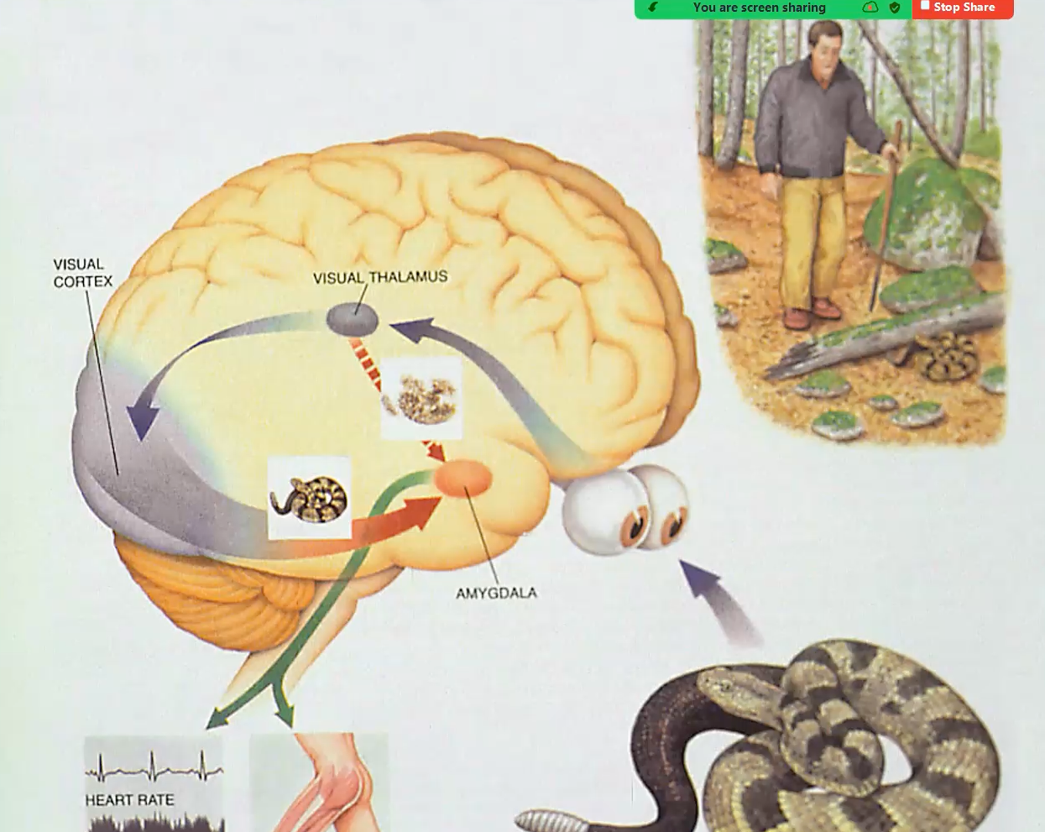 It is the high road and low road to the amygdala. Visual information comes in for example, this man is walking in the forest and sees a snake. That information goes to the Thalamus, and there is a very crude, rapid, image that's sent to the amygdala that happens outside of conscious awareness, and that triggers somatic motor responses and viscera motor responses. Then that information proceeds to the visual cortex, and it's processed consciously. That takes a longer period, around 100 milliseconds. The Freudian model said you either had conscious emotional experience or nothing. This is saying, you can have a bodily emotional response without conscious experience of feeling. 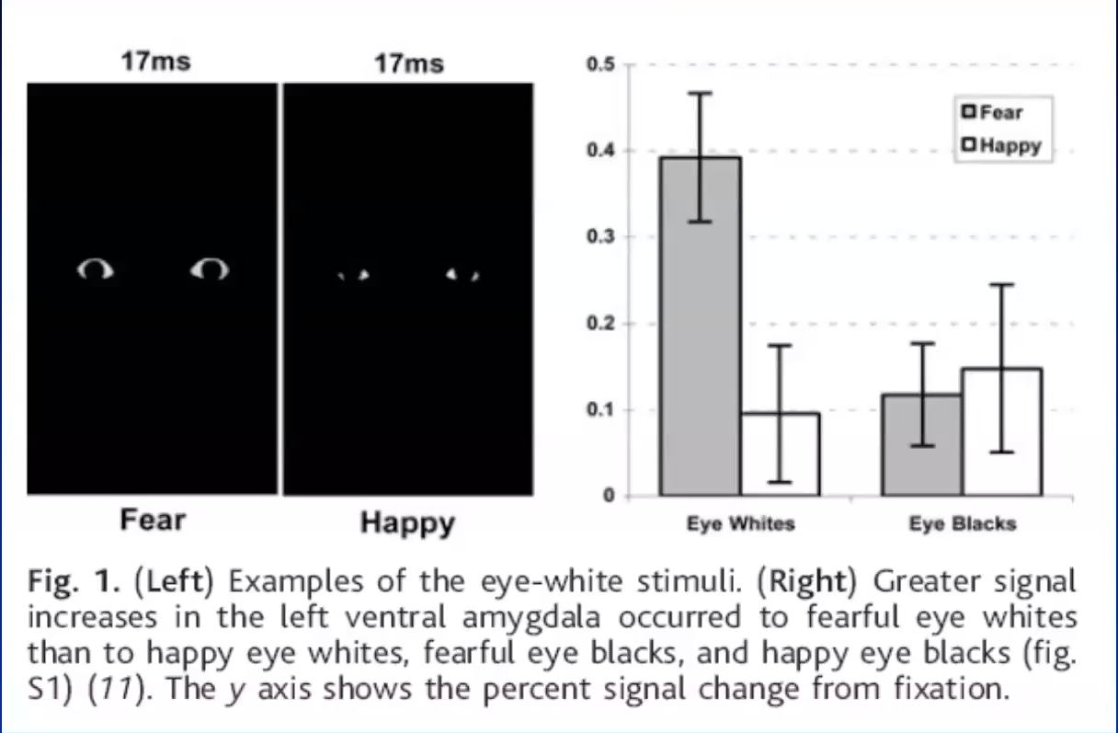
Here is another example of a clever imaging study where eye whites are presented very briefly, and it's followed by a backward neutral mask. The amygdala responds to these eye whites fear much less than to happiness. A prevailing idea in cognitive neuroscience is that about 99% of cognition is implicit or unconscious. The same may be true for emotion to the extent that we're constantly evaluating for emotional significance the extent to which our needs or values are being met or not met, and our bodies are reacting. We don't always feel emotions because we're often occupied with other things like listening to a lecture, for example. Lisa Feldman Barrett is really the leading proponent of this alternative view. I think she's done remarkable work in her career to really garner evidence that a lot of previous conceptions are not adequately supported by the data, but also doing work to show support for an alternative view. This view is that emotional feelings are constructed, and that they're based on concepts, and that language helps constitute the experience. As an example of the kind of work that she did I showed you one imaging study by Damasio, but she and Tor Wager and others have developed techniques for doing meta-analyses of neuroimaging data. They aggregated 162 different imaging studies of emotion and they let machine learning identify how does the data cluster together. It did not cluster together in terms of different basic emotions. What did cluster together were different networks. You see them color coded here.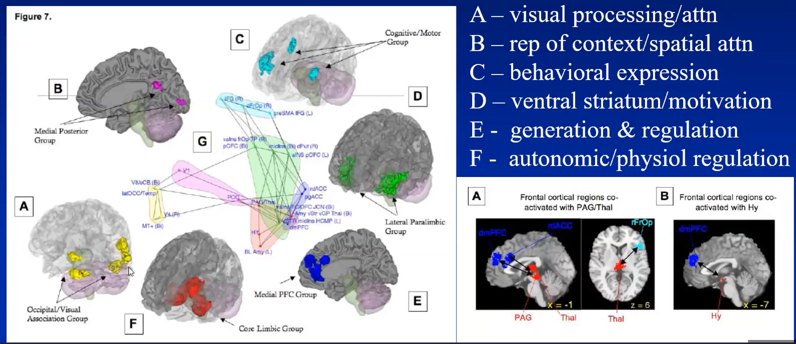

These imaging studies involve emotion, and a controlled condition, and they're looking at what's activated in the brain, and what's more activated in emotion relative to the control condition. There is a lot of activation in the visual processing system. We know that the amygdala projects directly back to the visual cortex. That's why we're more alert to signs of danger when we're afraid. Cluster B in the medial posterior cortex. This is where there's a representation of context and spatial attention. There's a mode where a cognitive and motor group which involves the behavioral expression of emotion. D. Ventral Striatum and motivation. E. The medial prefrontal group involving the generation and regulation of emotion and F. autonomic and physiological regulation. In other words, there are a lot of different systems involved in executing an emotional response. It's not just all about the experience which is what we focus on. Moreover, their analyses showed that what was commonly seen and emerged from the data were these connections between the frontal cortical regions and subcortical regions involved in the generation of affective responses, or execution and monitoring of bodily responses. Connections between medial prefrontal cortex and thalamus, or in the periaqueductal gray, as well as to the hypothalamus. This corresponds to the argument that the medial prefrontal cortex and theory of mind involves a kind of re-representation of bodily and emotion responses at the cortical level and at the conceptual level.
Here are some conclusions from recent emotion research. It's impossible to determine what emotion is activated in a person based on objective measurements. There are no autonomic signatures that differentiate specific emotions using peripheral or physiological monitoring. Moreover, there's no functional neuro anatomy that distinguishes between specific emotions using functional neuroimaging. Moreover, there are no brain structures exclusively devoted to emotion or cognition, and complex, cognitive, and emotional functions are thought to be mediated by interacting brain networks. 20 years ago, I attended a lecture, in a human brain mapping conference in Japan, and Marsel Mesulum, a leading neurologist, and wrote the textbooks on Behavioral Neurology, gave the introductory keynote lecture. He said the reason functional MRI has been so phenomenally successful is that it measures brain function on the same spatial scale as complex mental states, that is, cognitive emotional functions, as they're mediated in the brain. fMRI scans the whole brain every 3 seconds and they're very complex patterns, as we saw from that meta-analysis involved in mediating these functions. This is a paper from Lisa Feldman Barrett that describes the evolution of our thinking in terms of neural substrate.
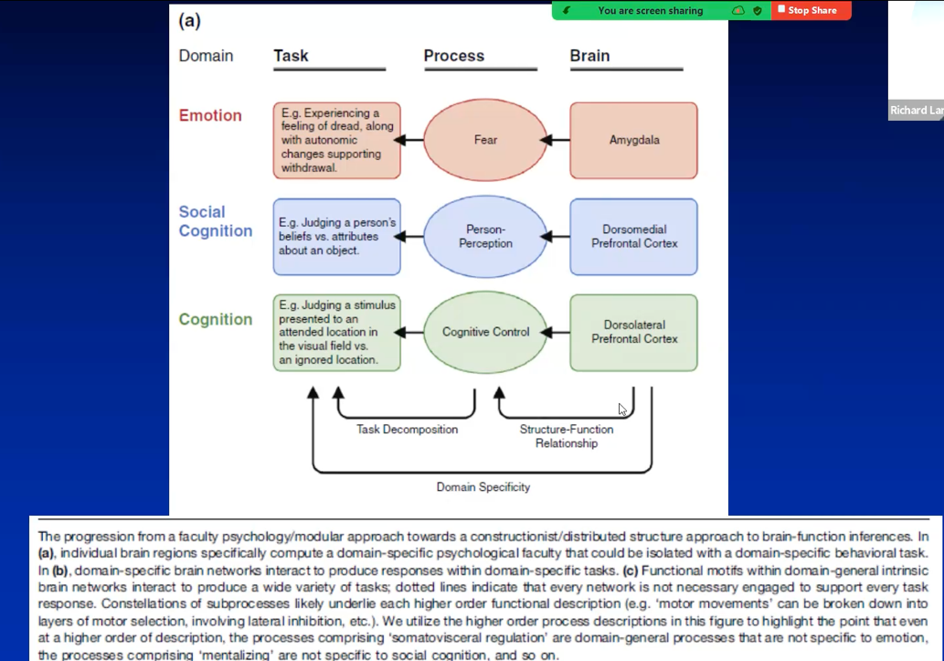
So we can talk about emotion, social cognition, thought or cognition. You might think of this in a simple way as we are afraid, it is mediated by the amygdala. Social Cognition is mediated by the dorsomedial prefrontal cortex. One brain area leads to one process. However, that's too simple. What about a network that's domain specific?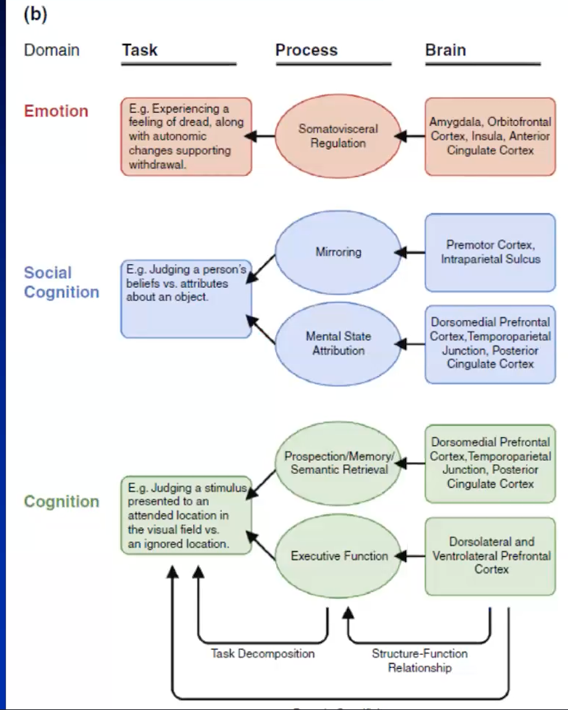
A domain specific network for emotion involving amygdala, orbital cortex, insula, anterior cingulate cortex. A domain specific network for social cognition, a domain specific network for cognition. That is a second more complex model but it's not the model that we 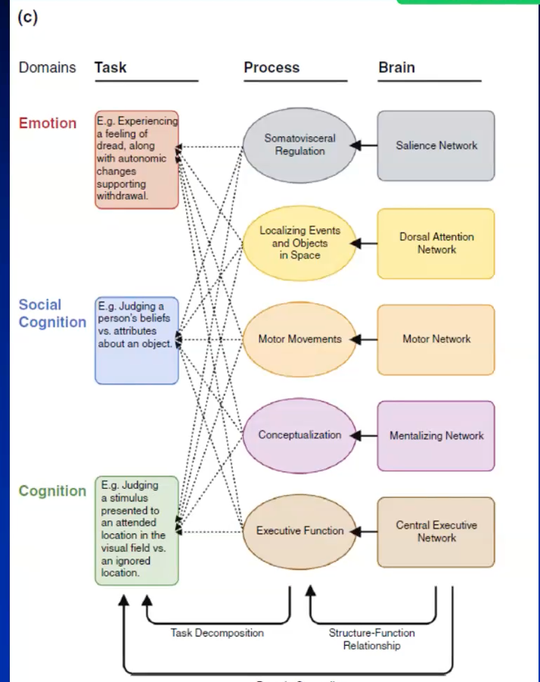

think makes sense now. The model that makes sense now is that emotion involves all these different processes (i.e., somatic motor visceral regulation, attentional mechanisms, motor function, conceptualization, regulation, executive functions). All these networks are involved, and all these networks are similarly involved in social cognition and thought. It is just very complex. But it's better to acknowledge what the data is telling us rather than pretending it's not telling us what it is telling us.
This brings me to my way of thinking about this impairment in emotional experiencing from this more systems neuroscience perspective. That is not about defense but it's about something else. These ideas have developed over the past 25 years. It took me over a decade to figure out what to call it. But I found that the term, affective agnosia, really captured it. I was surprised, and delighted to learn that the person who coined the concept of agnosia was Sigmund Freud in 1891 when he was a neurologist before he created psychoanalysis. In this review article, in 2015, we say, affective agnosia expansion of the alexithymia construct and a new opportunity to integrate and extend Freud's legacy.
Is alexithymia an anomia or agnosia? We have some medical students here. How many people know the difference between anomia and agnosia. Alexithymia means lacking words for emotion. That corresponds to an anomia. With anomia, you know what an object is, but you can't name it. In agnosia, you can't recognize an object, and therefore you can't name it. This item (harmonica), you might recognize as a musical instrument. You might be able to hear in your mind what it sounds like. Stevie Wonder, the Beatles and Bob Dylan played it. But you can't think of the word. If you have no idea about what it is, you might say something with teeth. Agnosia is a recognition failure. You can see it, the perception is intact, but it results from a breakdown of the link between perception of an object and stored knowledge about it. 

Now, all of you remember this image from the first lecture. Now, when you look at that are you baffled as you were originally or not? Or do you see it for what it to be? This illustrates the difference between anomia and agnosia. Did you know what it was but couldn't name it? Anomia. Or did you not know what it was, and therefore couldn't name it or describe it. Agnosia. The point is when you first saw it you had no idea what it was, but now you do, and so you have a mental representation of it.
Sigmund Freud in 1891 termed Agnosia for disturbances, and the recognition of objects which Finkelnburg called asymbolia. I should like to propose the term Agnosia. What Freud observed was, you have the object, and you have the word harmonica. In between you have this mental representation. You have the idea or the knowledge about like what it is and what it sounds like, etc. If you have that mental representation, but don't have the word that's an asymbolia or anomia but Freud pointed out, hey, if you don't even know what the heck it is, then it's an agnosia. How does this apply to alexithymia? Alexithymia literally means lacking words for emotion. People seem completely unable to describe emotion. They may not even have emotion. But let's just call it alexithymia because we know for sure that they can't describe it. This is an important distinction between anomia and agnosia. Here is the anomia version. In the domain of emotion, the “perceptual stimulus” is interoceptive: the implicit, (visceromotor/behavioral) emotional response. It can be mentally represented, experienced, and known. Alexithymia individuals have difficulty describing (cognitively elaborating upon) what they perceive, experience, and know. In the patient that I presented, she was experiencing grief, she just couldn't describe it. Alternatively, she didn't did not know what she was experiencing. In affective agnosia, there's a failure to mentally represent an implicit emotional response which is associated with deficits, and experiencing, knowing, and describing one's own emotions. She experienced it in her body, and she had abdominal pain and got admitted to the hospital for that. She did not experience it as grief. In this 2015 paper, we presented a neuro anatomical model of affective agnosia. We said in the case that I presented, that you have emotion that is generated subcortically, but the activity doesn't go to the medial prefrontal cortex because, as I said, it's experienced as high arousal and gone offline. So, then you have a bodily response, and you don't know what to make of it, and you get very frightened, and you think ‘oh, I am very sick’, and that increases your fear and increases your anxiety, which makes the pain worst. It is a positive feedback loop that leads you to go to the doctor, and then the doctor can't find anything, so then they call psychiatry. However, engagement of medial prefrontal cortex and connection to constructed conceptualization, “Oh, I’m feeling grief that's appropriate because my mother died,” that changes how the brain operates.
The alternative is the following. This is taken from Les Greenberg where he talks about the distinction between the lived story and the told story. Emotions are activated, and they create bodily felt experience which could include somatic symptoms. Then you put it into words, it becomes the told story, and you create a mental representation of that experience. Now, critically, this is a bi-directional arrow such that when you create a mental representation, it then creates a shift in the body and what you experience, because that's related to the connections and communication between the medial prefrontal cortex and the subcortical structures that I talked about. Putting into words a shift in what you feel, and that shift then becomes the basis for additional description. It is a dialectical cycle of meaning construction from experiencing to explaining, going round and round. The more you do that, the bigger your repertoire, and the bigger your Crayola box is. The less you do it, for instance, you've had early adversity and you avoid dealing with your emotions, it remains small, impoverished, and you're prone to somatization.
So, conclusions. Psychoanalysis has placed primary emphasis on emotions as threatening and dangerous, and defenses as controlling them. It is assumed that if defenses are overcome, emotions will be experienced. A broader view of emotions as adaptive and providing useful information about needs has emerged from more recent research. Current evidence suggests that differentiated emotional experiences are learned concepts. Bodily emotional responses without feeling are quite common. For some patients. particularly those with early life trauma, overcoming defense is not sufficient to experience emotion and can require assistance in formulating emotion for the first time in the context that the person is currently in. It's a big difference between mother almost dying versus mother being gone. Although Freud never applied the concept of agnosia, lack of mental representation, to psychoanalysis because they only dealt with that which had been not represented previously. The concept fits the phenomenon of un-mentalized emotion rather well, consistent with current knowledge about the functional neuroanatomy that have constructed emotional experiences.

