Lecture 6: Emotional awareness: Evolution, Development and Consequences of Trauma

I thought that today I would talk about levels of emotional awareness, theory, measurement, and findings. This is the constructionist view of emotion in contrast to the Paankseft and Solms view. I thought it would be best to give you a clear exposition of the whole theory and the measurement, and the findings to date in preparation for next week when we talk about impairments and emotional awareness, and how it presents clinically. The following week, we'll talk about how to intervene. To give you the full background, I thought I would spend the first few minutes talking about evolution of our capacity to be aware of our own emotions. It's only human beings who can reflect on our own experiences. I really believe that our other creatures, our closest primates, can’t do that. A main point that I want to emphasize is that our expanded and large brains as human beings create the capability for reflective awareness, but it doesn't automatically happen. It really is dependent on our environmental experience growing up. It really determines what becomes of this capability, and whether it reaches fruition or not. After that background. I will tell you the formal theory of levels of emotional awareness. Briefly, I’ll tell you about how we measure it, and then I’ll tell you the findings that we've obtained through the years with the levels of emotional awareness scale. The theory was developed and published in 1987. That was 35 years ago. At the time there was no measurement of emotion awareness, it was just a pure theory. We created a measure based on that theory, and it turned out to be a strong psychometric instrument. There are 230 publications on emotional awareness, I’ll highlight some of the major findings for you today.
One of the readings that you have in your reading list is this paper written by collaborators in in Arizona. Together we published this complex paper, talking about how the unique human capacity for emotional awareness evolved, and how it developed. We compared with anatomical, cognitive, neural, computational, and evolutionary psychological perspectives. I am showing you here the vast expansion of the prefrontal cortex in human beings relative to other primates and other familiar animals. This is a figure taken from that paper where the basic idea is that this expanded size of the prefrontal cortex makes it possible to have more elaborate computations that go beyond the immediate present and make it possible to detect longer time scale regularities that then enable more complex processes that are necessary for reflective cognition in general and reflection as it applies to emotion. Neocortical expansion in humans creates the capacity to reflect upon or be aware of one's own emotional experiences but doesn't absolutely determine it. The disproportionate cortical expansion during evolution, reflects additional hierarchical levels of computational processing allowing representation of multimodal regularities over longer time scales. These representations make possible abstract concept learning, internal simulation of distal future outcomes, and expanded working memory capacity. These allow for the ability to simulate emotions like imagine how someone else is feeling, to learn emotion concepts and to manipulate them, and working memory when deciding how to act. If you think about, should I do this or that, how will this person respond, how will I feel, what if I do this other thing, that all involves holding things in conscious awareness, in working memory, we think that is a unique human capacity regarding reflection.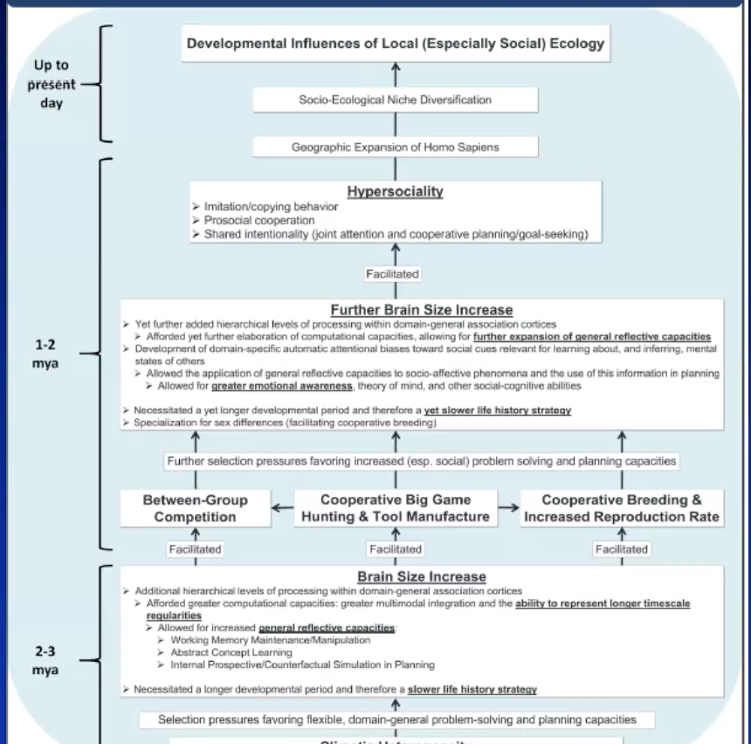
This is a figure from that paper, and it talks about the evolutionary pressures that contributed to becoming a hyper social species. The main point, what I want you to take away, is it just creates the capacity for emotional awareness.
A concept of life, history, and strategy which is the environmental determination of whether higher emotional awareness develops. It's cool that we're able to draw on this concept from evolutionary biology. There is a fundamental trade off with the lifetime allocation of finite energy resources to either somatic growth and development or reproduction. There's a primary goal, or biological imperative for the species to survive. You can either focus on a smaller number of people, or organisms facilitating their somatic growth in development or reproduce with many offspring. We talk about fast and slow life history strategy. Speed refers to the time to maturation, and the longevity of the organism. In general, humans are a slower life history strategy species but within the species they're variations, whether slow or fast. If environmental conditions are harsh and unpredictable the best strategy is less investment and more offspring You have the best outcome that way versus if environmental conditions are safe and secure, more investment and fewer number of offspring is an effective strategy. That is a slow life history strategy. When it comes to emotional development, contingent mirroring and responsiveness is essential. Part of what makes for slow life history strategy is the ability to know what is going on in our own minds. Initially, childhood requires reliable input from others about the meaning of our own bodily responses. Slow life history strategy is associated with greater time and effort devoted to the emotional development of children. Children learn that emotional signals have meaning and that it's useful to pay attention to them. Regarding this, it's useful to refer to Maslow’s hierarchy of needs put forward in 1943, pointing out that first people need to meet their physiological needs just to stay alive. Then safety and security. Only after those are taken care of, love and belonging, after that self-esteem, and then the highest-level would-be self-actualization. In the context of abuse or neglect, basic survival biological and psychological, is the top priority. If the environment is safe and secure, promoting attachment, self-esteem and self-actualization become possible. Emotional awareness plays a key role in developing these capacities. 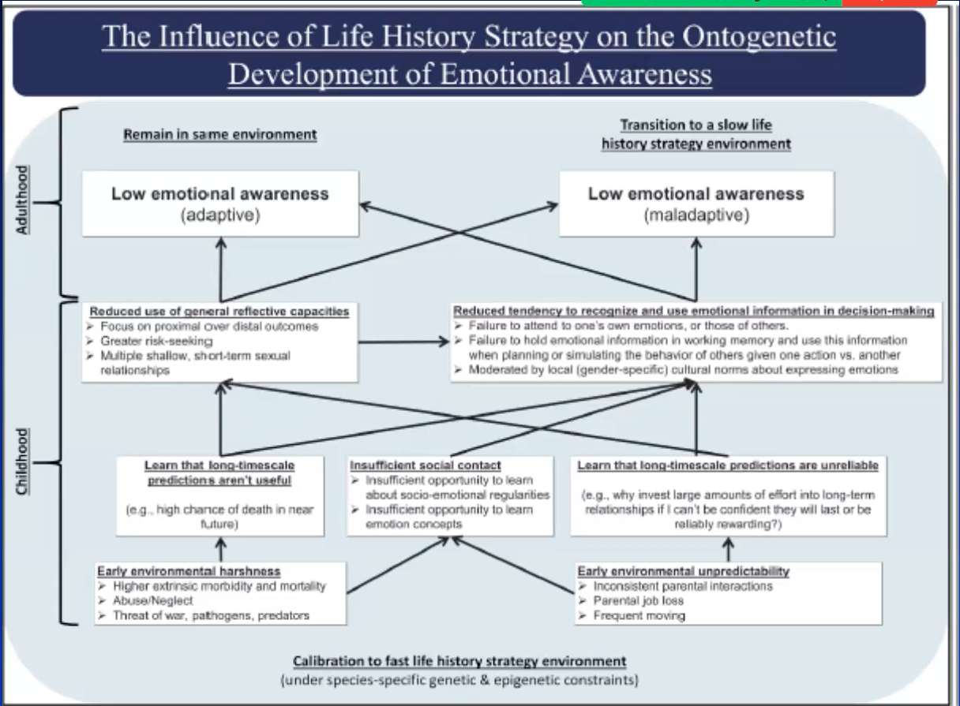This is another figure from this paper talking about the influence of life, history, strategy onto genetic development of emotional awareness. It illustrates what happens with that life, history, strategy. You have early environmental harshness with a higher extrinsic morbidity and mortality, abuse or neglect, threat of war pathogens of predators. If you're in that situation, you learn that long time scale predictions aren't useful because there's a high chance of death soon. With environmental unpredictability, you have inconsistent parental interactions, parental job loss, frequent moving. As a result, you have insufficient social contact and insufficient opportunity to learn about social emotional regularities and insufficient opportunity to learn emotion concepts. You learn that long time scale predictions are unreliable. Why invest large amounts of effort into long-term relationships that can't be confident that the last or being reliably rewarding? Reduced use of general reflective capacities you focus on proximal over distal outcomes, greater risk-seeking, multiple shallow short-term sexual relationships. Reduce tendency to recognize and use emotional information and decision making, failure to attend to one's own emotions or those of others. Failure to hold emotional information up in memory and use this information when planning or simulating the behavior of others given one action versus another. It is moderated by local gender-specific cultural norms about expressing emotions. The argument here is that it's adaptive in the fast life history environment to have low emotional awareness. If you have grown up with fast life history background with abuse and neglect, and then you're in a high or a fast life history strategy, environment then that can be mal adaptive.
Now, I’m going to tell you a little bit more about the consequences of emotional neglect, and how it affects connections between prefrontal cortex and the amygdala. This is work of Nim Tottenham and her colleagues at Columbia University. This is work that is done in human beings and continuity with animal work. There's a whole animal literature that goes along with this. She acquired resting state functional MRI in children at different ages. She showed that in healthy development there is a positive correlation between the amygdala and prefrontal cortex at rest that continues through childhood and into later adolescents. But then, in later adolescents and healthy development, there's a switch from a positive correlation to a negative correlation. The way to understand that is there's a lot of emotional learning going on bidirectional communication between the amygdala and prefrontal cortex, because in a healthy developing child, parents are providing the emotion regulation, they don't have to do it themselves. It becomes a negative correlation with prefrontal cortex and becomes more dominant and inhibiting the amygdala. What she observed was, in children who had been institutionalized and had emotional neglect, switched from positive to negative a few years earlier. I think what that means is that there's less emotional learning that goes on, and they become independent at a younger age. It creates vulnerability to the medial prefrontal cortex and going offline in the context of high arousal. The threshold for going offline is lower when you've had that reduced learning. This is another brain-oriented way of understanding emotional awareness, or the loss of it in the case of high arousal.
All that background for describing levels of emotional awareness. One of the things that motivated me to do this work on emotional awareness was my observations about alexithymia, which is lacking words for emotion. When I was in medical school, I had the opportunity to see lots of people who seem to be out of touch with their emotions. The concept of alexithymia had been put forward as a developmental arrest, some kind of lag in emotional development. The nature of the developmental line along which had been arrested, hadn't been defined. That was the basic idea of this. To define a line of emotional development that would bridge a normative and clinical context. Alexithymia would constitute low emotional awareness along this developmental line. I was interested in the work of Jean Piaget, from Geneva Switzerland, considered the father of cognitive development, describe different stages of cognitive development. As well as our own on Sigmund Freud here in Vienna, who had a developmental perspective thought that the problem we have as adults start in childhood. I was really interested in trying to bring these two developmental perspectives together and did that with this paper. Piaget talked about the structure of cognitive development becoming more differentiated and integrated over time. That was the fundamental idea here about emotional awareness. It becomes more differentiated and integrated over time. Just as Piaget said, Cognition starts with sensory motor patterns and concrete manipulations, and some real emotion starts in the body as a concrete medical station. Transition to abstractions, which become more differentiated and integrated. That's the basic parallel. Paul Ekman and the Dalai Lama were also influential. Paul Ekman helped advance scientific research on emotion and studied facial expressions and their universality. He is teaming up here with the Dalai Lama spiritual leader, the Buddhist religion. This book is titled, “Emotional Awareness,” overcoming the obstacles to a psychological balance and compassion. Emotional awareness is widely recognized to be important in psychotherapy. This paper from 2007 says “accurately recognizing emotions is critical to psychological health, and most major therapeutic approaches aim to address deficits and emotional awareness.” In psychodynamics it would be more overcoming defenses.
We have this cognitive developmental model of emotional awareness. At the time it was radical to say that being aware of your emotions as a cognitive skill, because for hundreds of years we thought of cognition and emotions totally separate domains. As we've learned more about the brain basis of these mental faculties, we realize that it's impossible to separate them because they're so overlapping. We talked about this last time, that there are no specific structures that are in the brain specifically devoted to emotion or cognition. The ability to be aware of one's own emotions is a cognitive skill like any other. This ability develops over time. Like Piaget’s stages of cognitive developmental, developmental transformations occur in the capacity to be aware of one's own feelings. According to Piaget, cognition becomes more differentiated and integrated with development, and we feel that the higher the level of emotion, awareness, the greater the differentiation, integration, and de-somatization of emotional experience and expression. By de-somatization, what I'm referring to is that emotion starts in the body and that as you go up the levels, a bodily component is still present, but it is less prominent in the experience.
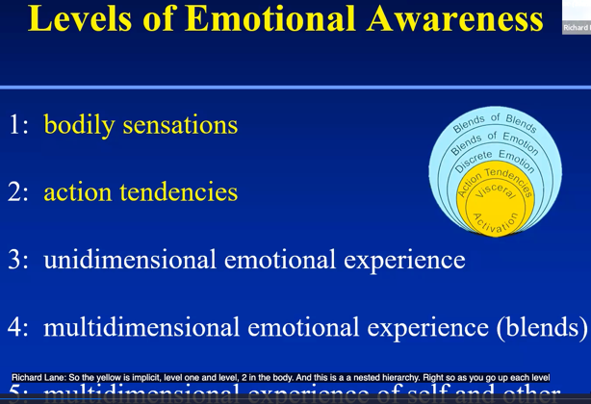
We described 5 levels of emotional awareness patterned after Piaget ‘state or stages of cognitive development. We talked about levels because these are coherent patterns of organization. Emotion switches very rapidly from one state to another. We refer to levels rather than stages. Level one is bodily sensations, and level 2 is action tendencies. When we say that emotion starts in the body, we evaluate what's going on in the moment, and we have action tendencies to approach or avoid, that need to be supported metabolically with physiological activation. That’s how we can understand levels one and two. We can also refer to these as implicit emotions, because when they're just bodily activations, it doesn't feel like an emotion yet. On the other hand, other people can see your facial expression, your posture, and your gestures, and might be able to recognize that you're having an emotional response. The yellow is implicit, level one and level two, in the body. This is a nested hierarchy. As you go up each level, levels before are modulated. This model is intended to describe both states and traits. For example, in the patient that I presented last week. The week before the mother died, she had grief. Grief would be like a specific emotional experience. That would be level 3. But then, after the mother died and she had physical pain, and she was back at level one. Level 3 is, unidimensional emotional experience, one emotion at a time like grief. Level 4 are blends of experience. Feeling happy and sad at the same time which is a developmental achievement. And it takes a few years before kids can experience two emotions at a time compared to one. At level 5, this is multi-dimensional experience of both self and other. To give you a feel for what these are like these are prototypical clinical expressions of different levels of most awareness. If someone is really focused on their bodily symptoms such as the patient, I presented last week with her abdominal pain in the context of losing her mother, that would be somatization of level one. Level 2 would be in the action tendencies clinically acting out as in borderline personality, disorder, acting impulsively. At level three, one emotion at a time. Clinically, if you're having a great experience, and you're happy. Great! That's level 3. When you do surveys of how people are feeling, generally it's happy, that's level 3. That's one emotion that's normal. Clinically, something like splitting where you can only experience one emotion or the other that would be level 3 functioning. Getting to level 4, when you can experience and accept conflicting emotions while would be in advance, relative to level 3, or happy, and sad at the same time. Level 5 is accurate empathy. For example, if you're doing psychotherapy and you're in touch with multiple emotional responses of your own and you're tuning into the multiple experiences that the patient is having and holding those in mind, and how might they be related to another, that's level 5 functioning. Another example of level functioning would be thinking about plans. For example, a partner relationship, each partner can move to a city for their dream job. How would you figure out which one you should do? You must think about the complexity of one situation and another and be able to compare them.
That was a theory from 35 years ago, and it basically is sound. I think it's also consistent with other advances in our understanding of the brain. We'll talk a lot about computational processes, particularly in subsequent lectures. What I focused on so far is the idea that if you have emotion that's activated, it starts in the body, and you need to mentally represent it with a concept which can be captured in language. We can call that, affective response representation. We created this three-process theory because we realized that if someone is not aware of emotions, it could be for any number of reasons. We had this one person who came to us because she said she didn't feel emotions. We studied her in the laboratory, and in fact, she was great at recognizing emotions and others, however, when it came to responding to emotion evoking pictures, she really had virtually no skin conductance responses. In other words, she wasn’t generating affective responses in the first place. You must have the affective response generated. That’s necessary to be aware of the emotion, you must have mental representation of what it is that you're feeling. That isn't enough because you must have conscious access, because emotions compete with other mental events, mental contents, thoughts, etc., for conscious broadcasting. This is another way of depicting these three processes. You have a situation that you're in, and you evaluate it. It generates these bodily responses, and there's a modulation of cognitive system. For example, if you're very afraid, you become very alert and notice stimuli that might be relevant to what you're afraid of, and so that's affective response generation. We have response representation but that then goes into the global neuronal workspace, to be consciously aware of it, and that is subject to cognitive control. So those are the three processes that contribute to emotional awareness. I've written a paper called alexithymia 3.0, saying that there's three different eras to the history of alexithymia research but the one we're in now, the third era, is one where alexithymia is a phenotype, and you can have the phenotype of alexithymia through any combination of these 3 processes. It's not just one thing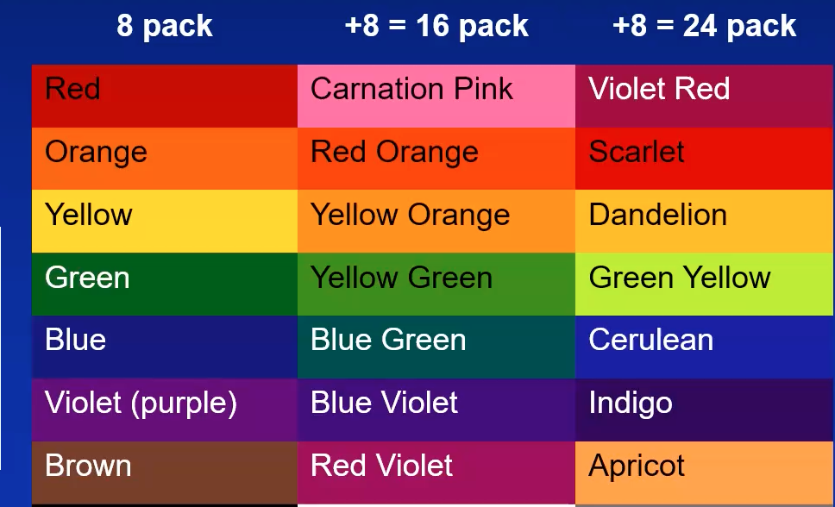.
The greater your level of emotional awareness, your capacity to be aware of emotions, the larger your repertoire available to you when you are in a situation and try to think about how you're feeling. You must draw on that repertoire to describe it, and some people have a very small pack of colors or crayons available to them, limited number of emotions, and then people vary in how many emotions are available in their repertoire. Experienced clinicians are in the hundreds and in our levels of emotion awareness scale, glossary has many hundreds of words that we draw on when we measure levels of emotional awareness. First, we drew up the theory, and then we had the task of creating a measure. I would like to point out that I did my residency in psychiatry, learned psycho dynamic psychotherapy, and was reading all these theories. I really believe that once you had the theory that was good, you had what you needed. In this research fellowship I got started with this great mentor, Gary Schwartz and within short order we finished the theory. He said, now we must see if it's true and we must create a scale. How are we going to measure this? One possibility was a self-report measure. We realized that for people to reliably rate themselves on awareness, they had to be aware of how, aware they were. If they had impaired awareness, then they might not be so good at accurately reporting on themselves. Therefore, we decided that we would just measure what people could produce in emotion evoking situations. We had this idea that language could drive the development of the skill. We originally created a 20-scenario version of this, where there are 20 different scenes, each described in 2 to 4 sentences, each involving 2 people. We asked, how would you feel, and how would the other person feel? We had a scoring system where it just involved picking up the emotion words, and seeing how differentiated they were and what level they were at. Psychometrically, we found that with a 10-item version that it was highly reliable. We didn't need all 20 and cut the time in half. It's still a time-consuming thing which has slowed the use of the scale. Over decades, we have lots of hundreds of papers. We're also developing computerized versions that still takes time for the subject to complete it but you don't need a research assistant to administer it, and you certainly don't need to spend time scoring it, because the scoring is done automatically. Subjects write as much or as little as needed to answer these two questions, and each of the 10 scenes is scored separately on a scale of 0-5. Here is an example. You and your best friend are in the same line of work and a surprise is given annually to the best performance of the year. One night the winner is announced to your friend. How would you feel? And how would your friend feel? I have a friend who keeps winning the prize every year. I have good experience with this. Scoring involves identifying the words and just assigning the score to the word. Bodily sensations like I feel sick, I feel dizzy, I feel tired would get a one. I feel like punching the wall, I feel like crying, that would be an action tendency. Or non-specific valence terms like feeling good or bad, would be a two. Good and bad are used all the time to describe emotion, but you they are most used in non-emotional contexts. At level 3, we're dealing with terms that are unequivocally emotion, that'd be like happy, anger, fear. There's no question that it's an emotion. At level 4 is 2 or more specific terms applied to self or other. We give a level 5 score when both self and other are level 4 and non-identical. I can tell you that in general, on a 20-item scale, women, on average, score higher than men, and they score in the mid to upper sixties, men in the lower sixties. It depends on the age but that averages to about a 3, or a little bit higher per item. I told you that the 20-item version is very reliable, and the 10-item version is comparably reliable adequately reliable to use on its own. Inter rater reliability is extremely high because there's no inference involved to speak of. This investigator in Las Vegas, Kim Barshart, who is very interested in emotional awareness, trained undergraduates who had no other background, and in 10 hours she could train them to do the scoring and get very high inter-rater reliability across 18 students. Test for test reliability is pretty good and acceptable but limited in some ways by the fact that emotional awareness is sensitive to different states and different conditions. There is going to be some variability there. It is performing as we hoped it would. The levels of emotional awareness scale have strong psychometric properties, and it's incorporated into what's called the RDOC Matrix, the Research Domain Criteria Matrix at the National Institute of Mental health. This is a big project where they're trying to study people with psychiatric disorders but trying to study basic processes to find new ways of clustering people together, aside from the traditional diagnostic categories. One such domain that's being studied are social processes and levels of emotional awareness scale is in this domain under the construct of perception, specifically, the understanding of self, and sub construct of self-knowledge. As we say in the United States, a good housekeeping seal of approval. It's recommended for use to study this. It’s one of 5 measures in the category that I listed. So, as I said, there are 230 papers to date, and there's a children's version of the scale that can be used in children age, 8 to 18. I gave you that one scenario of you’re at work and you're competing for a prize. Well, the scenarios are a little bit different. You're at school, you have a teacher, you don't have a boss, you’re on the playground you're not going out to dinner. The scoring system is basically the same, and there's some very large data sets that show that this scale is useful and reliable in children.
We also did an ecological momentary assessment study with a team in in Amsterdam that took undergraduate students. We gave them smartphones when they page them times a day. They asked them to speak into the phone and just say, how are you feeling now, and how's the person that you're interacting with feeling? If you're not interacting with someone, think about the last person you were interacting with, and how they were feeling. They did that for 2 days and on average they were able to get 10 different events that could be transcribed and scored. They also completed the standard levels of emotion scale (the 10-item version), with the hypothetical scenarios. It turned out that the correlation between the two, was .7, which is quite high and quite good. But then we're also able to look at the variability across these 10 different occasions, and 50 % of the variance was state related. It really helps provide empirical support for the theory that emotional awareness shifts as a function of the state that you're in, but on average, higher emotional awareness will have you operating at a higher mean level. That's more of the trait interpretation.
The levels of emotional awareness scale have been translated into 20 languages, and since 2010 we've been using an automated version in English, and just last month we published a second automated version in German. So much credit to Julian Herpertz and Md. PhD student from the University of Munster who came to Tucson for a couple of months, and we planned this whole data collection that we did in Germany. It was in Baham actually, a couple of community dwellers. We were able to validate this German version of the eLEAS. Germany and Austria are relative Mecca for psychotherapy and psychosomatic research, I am finding multiple opportunities to apply this new electronic method to existing data sets. That's part of the fellowship that I’m doing. I hope to tell you about some good results, toward the end of the fellowship here at the end of the course. We have a collaborator in Israel who is working on Hebrew and Arabic electronic versions. Those should be ready by the end of the year. When you have an electronic scoring system, not only can you look across the entire protocol and find relevant variables across the 10 items. To list all the level words that people use would be a good measure of the emotional range in and of itself. However, because we have the scoring system set up and you have a certain text, and it's basically a lookup table, you can take any text and evaluate it using the scoring system. That is what we're doing, for example, with adult attachment interviews. We can take those questions about childhood experiences and what was your relationship like with your mother and with your father, and we can put it through the scoring system to identify every scorable word in a text sample, assign the level scores, eliminate duplicates, and generate the sum. We can also count the number of words to control for that.
There’s another index that we're starting to experiment with, which is multi-level responses identifying whether both implicit level one and level 2 responses, and explicit, that is level 3 are included in each text sample. What we're really interested in here is that transformation from a bodily state to a mentally represented state. We think that we might be able to capture that by within text samples themselves. The computerized scoring system we have generally works well, but there are a few imperfections. For example, a word like “like,” can have an emotional meeting or a non-emotional meeting. There's value in creating a system with natural language processing that can look at context and can determine whether it's being used in an emotional sense or not, and appropriateness. We are only looking at the structure of responses. The different scenarios are targeting certain kinds of emotions like the one about the prize. There's happiness, there's disappointment, worry, or whatever. With natural language processing you can get at the sentiment that's being expressed. We can see if a scenario targeting happiness, expresses any happiness related words or not, and that's relevant in psychiatric context, where, for example, you might expect, and we do find, in a study of PTSD for example, that scenarios that we're targeting positive emotions we're not leading to positive emotional responses but were leading to high scores because people were talking about guilt, worry, shame, and situations where you'd expect them to feel good.
The Germany electronic levels of emotional awareness scale. And we have a standard battery that we use to help demonstrate whether it's working properly. We expect that there will be sex differences, that women always score higher than men, and that was true here. We consistently find that higher scores and levels of emotional awareness associated with greater ability to recognize facial expressions accurately. The correlation is like .43. I think that's an interesting finding, because these scenarios are just hypothetical, and people are just making things up. Yet, that level of differentiation really does correspond to actual ability to recognize emotions. Mental state stories, the theory of mind function, are ways of quickly giving sample items to look at the ability to make inferences about whether people have false beliefs or not, and that correlates with levels of emotional awareness. Verbal ability does also correlate with emotional awareness. I think a way of thinking about this is, and there's evidence to support this from some recent papers, that there's this domain general capacity for reflective functioning. That can be applied to different domains, and here it's being applied to the specific domain of emotion. There are positive associations between the emotional awareness scale score and verbal ability in the range of .3. It does vary with education level and with socioeconomic status, but it's not exclusively determined by that. An example of how verbal ability plays a role, women's score higher than men on emotional awareness, and woman score higher on verbal ability, but when you control from verbal ability, it's still higher for woman than men. Discriminant validity. Our chief competitor was the Toronto alexithymia scale, which was created after the levels of emotional awareness scale. It is a self-report measure that can be completed in 5 minutes. It's used in thousands of studies, but it has some of the problems that you might expect with a self-report measure. You can say that it's going to be valid in people who don't have impaired awareness, because then they're aware, and they can accurately rate themselves. The correlation between LEASs and TAS 20 is low, and it's negative, and there's Meta analyses on it, and lots of reasons why they don't measure the same thing. One of the things about the Toronto Alexithymia Scale is that it correlates positively with negative affect, however the LEAS does not. That is very relevant in medical and mental health context. For example, if you are interested in coronary artery disease, we know that people who are depressed and have coronary artery disease, have a shortened lifespan compared to those who are not depressed. But you'd want to know, in addition to that, is there any interference with the ability to be aware of emotions independent of what they can report about their distress? So, LEAS is good at teasing that apart, whereas TAS is confounded by that. There are 4 different studies where you find group differences with the TAS 20. When you control for negative affect, the difference between the groups goes away, the difference between groups persists when you do not control for negative affect.
Sex differences, openness to feelings, one of 5 major factors of personality. Several different studies show higher emotional awareness with good or openness to feelings is associated with greater recognition, accuracy in faces, more blends, progression, stories in an emotional intelligence test, greater range differentiation of emotional experiences. People of higher emotional awareness have more social support. A nice study demonstrates a stable sense of well-being, despite being in a negative mood. Take a group of people and ask them, how's life in general? They rate their well, which is pretty good, and then you induce a negative mood. In the people with low emotional awareness when you ask them, now that you're in a bad mood, how would you rate your general well-being now? It goes down. and the people with low emotion awareness, whereas in the people with higher emotional awareness it doesn't go down. If anything, it goes up a little bit. Speaking to the capacity to create mental representations of emotional state that are stable.
I talked about the top-down modulation ideas. You go up each level, levels that came before are more differentiated or integrated. There are 3 different examples of that. We did a an ecological momentary assessment study of 150 people. This is a major Grant for people at risk for cardiac arrythmias. We page them 10 times a day for 3 days. Every time we page them about 90 min apart. They answered 50 questions, which included 20 emotion items and 8 somatic symptoms, and then social context. We also had a 12 lead ECG and got some interesting findings there. Of course, we measured emotional awareness, and we were interested in the question of whether people rate their somatic symptoms in a more differentiated manner, for higher emotional awareness. What you can do is you can take the 8 somatic symptoms and do bivariant correlations. People who somaticize a lot, if you ask them about different somatic symptoms, they'll say yes to everything. Whereas the opposite would be true with higher emotion awareness. You can quantify this with bivariate correlations, and you take all the possible combinations of bivariate correlations with the symptoms, and if they are rated in a similar manner together, then the correlations are high. You aggregate these bi variate correlations. A more differentiated rating would be a low but average bivariate correlation. And that's what we found. The higher the emotional awareness, the lower the bivariate correlation, or the more differentiated somatic symptoms are. Several studies showing higher emotional awareness are associated with better impulse control and heart rate variability, which is a measure of cardiac vagal tone. The idea here which you've had for some time prior to getting this data was, we're talking about greater experiential complexity that we think, is supported by greater physiological complexity. Heart rate variability has to do with inter beat intervals, and how they vary with respiration and higher heart rate variability means greater vagal tone, more complexity. We found the positive correlation that we predicted. Higher reported self-awareness was associated with greater self-reported empathy but there's also very nice behavioral data in 150 couples, basically showing that in a task where you have people interacting, and then you review it on videotape, and each person rates how they felt, and then offline each person rates how they think their partner felt, the accuracy is higher as knowing what their partner felt, if you have higher emotional awareness.
Lots of findings regarding psychiatric disorders, borderline personality disorder, PTSD, depression, and anxiety have mixed findings having to do with this lack of association with negative affect. There are lots of findings regarding substance abuse, eating disorders, somatoform disorder, doing some work on psychopathy now, and we will say more about this later. Emotional awareness at baseline predicts better psychotherapy outcome. This is a treatment study with patients with panic disorder who are randomized to either manualize, psychodynamic psychotherapy or CBT and higher baseline emotion awareness associated with better outcome in both modalities. Regarding systemic medical disorders, nice finding about the central hypertension versus hypertension due to medical conditions like kidney disease. We found that emotional awareness was lower in essential hypertension compared to secondary consistent with essential hypertension, being a psychosomatic condition, or something that's related to psychological state. Another very interesting finding is that in irritable ball syndrome lower emotional awareness is associated with greater pain on a typical day which is consistent with the more somatic focus of the stress. We're doing interesting work on emotional awareness and pain.
There's now been 9 imaging studies using functional, structural, and resting state that do provide validation for this concept. LEAS correlates with areas involved in interoception, attention, emotional working memory, and metacognition. Emotional awareness is associated with increased cortical thickness in limbic but not default network. However, there is increase connectivity in default and salience networks, more efficient global integration across the whole brain, and increased neural response to subliminal, happy faces. An imaging study looking at moving geometric shapes led to a greater engagement in somatic processing, less pre-motor activity and higher emotional awareness people. Greater medial prefrontal cortex engagement in emotional working memory study that I’m going to tell you about. I think this is the best evidence so far about the neural basis of emotional awareness and the whole construct. This was Ryan Smiths idea. He thought we should use international, affective picture system pictures and in an emotional working paradigm. There were 4 different conditions. The idea is you look at the picture. and then you hold in mind something about your experience after seeing the picture. For example, in one condition you hold in mind for 5 seconds after the picture goes up, how the picture made you feel, and then a second condition where you hold in mind what you feel in your body. In a third condition, you see the picture and you just rest; in a 4th condition, you think about what the image was that you looked at, externally focused on that one. This was conducted in 26 volunteer students. The main effect of emotion versus body showed nothing which is interesting. You focus on your body, you focus on how you feel, across the whole sample there was no difference. However, there was a difference in some people, and, when you looked at the medial prefrontal cortex, the higher your emotional awareness, the greater the activity in the medial prefrontal cortex as a function of this difference. This means lower emotional awareness, emotion that is in the body, higher emotional awareness, greater engagement with the medial prefrontal cortex to make it an experience of an emotion as opposed to a bodily experience. The higher your emotional awareness, the greater the engagement of the medial prefrontal cortex experiencing emotion relative to a bodily focus.
There are three different studies showing positive correlation with heart rate variability. And now there are 10 different studies showing that interventions can increase level of emotional awareness. We started off with less targeted interventions initially. Claudia Subic Wrana in Cologne did a very large study on psychosomatic inpatient unit and showed that people with somatoform had lower emotional awareness, and emotion awareness significantly increased after months of multimodal treatment. We've had several different studies in our therapy, showing that emotional awareness increases. Then there were some interventions designed to improve emotional awareness, including in pain specifically. Mark Lumley has developed something called emotional awareness and expression therapy for fibromyalgia that leads to significant improvements in pain and outperform CBT. When people improve their emotional awareness also went up. More recently, there have been some large-scale studies where we have some good controls. I'll just point out that in the past year or so we've gone from 5 studies to 10, and so it's pretty convincing now that emotional awareness can be trained and can be increased. One such study was done in Arizona, and we just published this in the journal of Emotion, which is a prestigious journal. This was studied based on a 5-million-dollar grant from the military to my friend and colleagues at Scott Kilgore to train soldiers to increase their emotional intelligence. It's an online training program, 10 hours of online training and a total of 400 subjects. They were randomized to emotional intelligence training, or placebo treatment. The placebo treatment was 10 hours of training about the scientific method, making observations making measurements, doing analyses, reaching conclusions about the external world. What they showed was that there was a significant increase in emotional awareness in the emotional intelligence training and no significant increase in the placebo group.
There's another recent study from Turkey, of 120 nursing students. They were randomized to three conditions. One was emotional awareness training, 10 sessions 1.5 – 2hours focused on instruction and emotional awareness. I'll tell you what that was in a moment. Then the Placebo group involved 40 students who met 10 times from 90 minutes to 2 hours, and they had an open discussion about nursing school and being in nursing school, but it wasn't structured. The control group had one hour of instruction on emotional awareness skills at the very end and they didn’t increase at all. What did this emotional intelligence training consist of? Well, they got acquainted in session one. Then in session two they started to develop a vocabulary for expressing emotions. In session three they learned about the relationship between emotion and behavior. In session 4, they learned to express emotions with body language. Session 5: expressing emotions with “me” Language. In session 6, becoming aware of primary and secondary emotions. Primary emotion would be, you've been abused, you're very afraid, but then secondary emotion, the primary adaptive emotion would be anger. You can have primary motions, and then emotions in response to those primary motions that's primary and secondary. Session 7 would be developing emotional self-expression skills, session 8 would be developing skills of listening with empathy and reacting empathically. Session 9 would be learning to accept emotions that are hard to accept. So, all that training led to significant increases in emotional awareness. Several months later the emotional awareness instruction group seemed to continue to go up because they were practicing.
Levels of emotional awareness captures the structure of emotional experience in both state and trait contexts. The body of empirical evidence supporting the theory of levels of emotional awareness is now both broad and coherent. Behaviorally, levels of emotional awareness capture a learned social emotional skill. Abundant evidence that higher levels of emotional awareness are associated with better mental and physical health. A possible model links individual differences in level of emotion awareness, brain structure and function and peripheral information transfer systems. I have shown you data regarding the autonomic nervous system. Higher vagal tone is anti-inflammatory. You start to see how that effects health. The internal working model of the social world maps the relation between internal emotional responses and experiences, and what is expected to transpire in the external world. Variations in the level of emotional awareness organize the structure of the differentiation and integration of the internal working model. Levels of emotional awareness, therefore, defines a plausible line of emotional development. Successful emotional development requires contingent mirroring and responsiveness from caregivers early in life and beyond. The levels of most emotional awareness model help to explain limitations in emotional development and provides guidance on how to further advance this capacity or skill which we'll be talking about in subsequent lectures.

