Scott Mackin, PhD
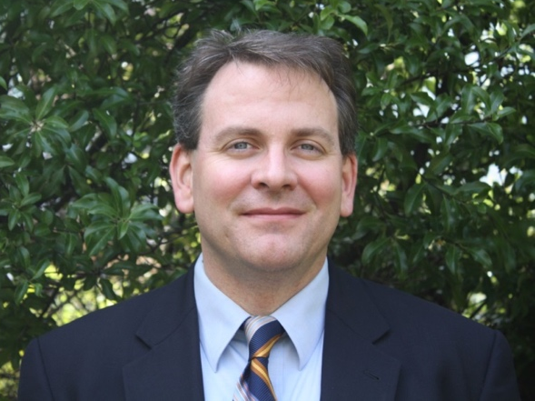
Dr. Mackin is a clinical neuropsychologist and Professor of Psychiatry in Residence at the University of California, San Francisco and the Director of the MIRECC Neuropsychology Fellowship at the San Francisco Veterans Affairs Medical Center. Dr. Mackin’s program of research is focused on identifying structural and functional brain abnormalities associated with depression in older adults and the mechanisms by which these abnormalities lead to accelerated cognitive decline and increased risk of Alzheimer’s disease.

His work in this area has been funded by the National Institute of Mental Health (NIMH), the Department of Defense (DOD), several philanthropic foundations, and private industry.

He is the Principal Investigator for three NIMH funded projects including the Alzheimer’s Disease Neuroimaging Initiative Depression Project conducted to evaluate amyloid deposition in individuals with LLD, a multimodal MRI study conducted to evaluate functional and structural brain changes resulting from successful treatment of depression in older adults, and a study evaluating neuropsychological functioning in older adults with comorbid psychiatric illness.

Dr. Mackin is also the lead neuropsychologist for The Brain Health Registry (BHR) an internet research registry developed to facilitate clinical trials for Alzheimer’s Disease and psychiatric disorders. Dr. Mackin’s work with the BHR has focused on the validation of online neuropsychological measures and developing new research methods to utilize online measures of cognition to promote clinical trials.

